战国风云游戏项目论文

Yichao Xu

***Abstract:***

"战国风云"是一个经典的策略游戏，玩家试图通过控制棋盘上的每一个领土来征服世界。

在游戏开始时，每个玩家将有一组军队。在每一回合中，他们将能够加强本领土的军队规模，并攻击由其对手控制的领土。[1]

该项目侧重于设计，实施，测试和评估一个电脑游戏，遵循规则，棋盘游戏"风险"与三个不同的游戏AI。

本文档是为最后一年的项目主管和参与者准备的。它将描述游戏的背景研究、设计、实施和评估。

Contents

**1.** **Introduction** 1

**1.1** **Problem Address** 1

**1.2** **Aims and Objectives** 1

**1.2.1** **Game Mechanics** 1

**1.2.2** **Game Aesthetics** 1

**1.3.** **Challenges and Solutions** 1

**1.3.1** **Game Logic Design** 1

**1.3.2** **Game Interface** 2

**1.3.3** **Artificial Intelligent** 2

**2.** **Background** 2

**2.1** **Question Background** 2

**2.2** **Existing Solutions** 2

**2.2.1** **Hasbro 战国风云** 2

**2.2.2** **Warzone** 3

**2.3** **Research** 3

**2.3.1** **Game Rules Research** 3

**2.3.2** **Game Engine Research** 3

**2.3.2** **Artificial Intelligent Research** 4

**2.4** **Requirements** 4

**3.** **Data Required** 4

**3.1** **Data Needed** 4

**3.2** **Data Sources** 5

**4.** **Revised Design** 5

**4.1** **Use case diagram** 5

**4.2** **Architecture Design** 10

**4.2.1** **View** 10

**4.2.2** **Model** 10

**4.2.3** **Controller** 11

**4.3**  **Abstract Specification** 11

**4.3.1** **Subsystem in View** 11

**4.3.2** **Subsystem in Controller** 11

**4.3.3** **Subsystem in Model** 11

**4.4** **Interface Design** 11

**4.4.1** **Map Board** 11

**4.4.1** **Functional Components** 12

**4.5** **Components Design** 13

**4.5.1** **Classes in View** 14

**4.5.2** **Classes in Controller** 14

**4.5.3** **Classes in Model** 15

**4.6** **AI Activity Diagram** 15

**4.7** **Data structure Design** 17

**4.7.1** **RelationMatrix** 17

**4.7.2** **PriorityOrderedList** 17

**4.7.3** **GameStrategy** 17

**4.7.4** **BalanceGraph and BalanceNode** 18

**4.8** **Algorithm Design** 19

**4.8.1** **Binary Searching** 19

**4.8.2** **FloodMin Algorithm** 19

**4.8.3** **Balance Calculating Algorithm** 20

**4.9** **Test Design** 20

**4.9.1** **System Test Design** 20

**4.9.2** **Cluster Test** 20

**4.9.3** **Unit Test** 20

**4.10** **Evaluation Design** 21

**4.10.1** **Self-evaluation** 21

**4.10.2** **3rd party Evaluation** 21

**4.10.3** **AI Evaluation** 22

**5.** **Realisation** 22

**5.1** **Implementation of View** 22

**5.1.1** **Game Map and UI Components** 22

**5.1.2** **Encapsulation to Unity GUI and WFPS** 23

**5.1.4** **Changes on View Design** 26

**5.1.5** **Problems Encountered in the game view** 27

**5.2** **Implementation of Controller** 29

**5.2.1** **Player Controller** 29

**5.2.2** **Player Controller Manager** 30

**5.2.3** **Command and Invoker** 31

**5.2.4** **Changes on Controller Design** 31

**5.2.5** **Problems Encountered on the game controller** 32

**5.3** **Implementation of Model** 34

**5.3.1** **Data and Data Model** 34

**5.3.2** **Input and Output** 35

**5.3.3** **Artificial Intelligent** 35

**5.3.4** **Changes in Model Design** 39

**5.3.5** **Problems Encountered on the game model** 39

**5.4** **Test** 42

**5.4.1** **System Test** 42

**5.4.1** **Cluster Test** 43

**5.4.1** **Unit Test** 44

**6.** **Evaluation** 45

**6.1** **Functional Point** 45

**6.2** **Self-evaluation** 45

**6.3** **AI Evaluation** 46

**7.** **Learning Point** 47

**7.1** **Lecture Content** 47

**7.2** **Programming Skill** 47

**7.3** **Project Management** 47

**8.** **Professional Issues** 48

**8.1** **Code of Good Practice** 48

**8.2** **Conduct** 48

**9.** **Bibliography** 49

**10.** **Appendices** 51

# **1. Introduction**

## **1.1 Problem Address**

战国风云 是一个经典的策略游戏，玩家试图通过控制棋盘上的每一个领土来征服世界[2]。游戏开始时，每个玩家将有固定数量的军队。在每一回合中，他们都会接受新兵，他们可以将这些新兵安置在她/他的任何领地上。征兵后，玩家将能够决定是否要攻击附近的对手的领土。项目试图解决的问题是如何设计、实施并且评估类似游戏。

## **1.2 Aims and Objectives**

项目的目标和目的就是设计、实施、测试和评估一种基于"战国风云"规则的回合制策略游戏，并且该游戏应该实现计算机AI。

根据杰西·谢尔的著作"游戏设计的艺术"[3]，游戏由四个基本元素组成，即“技术：任何材料和互动，使游戏可能实现”; “机制：游戏的逻辑和规则” ; “故事：在游戏中展开的事件序列”; “美学：游戏界面设计”。本文档将从游戏机制和游戏美学中详细描述目的和对象。

### **1.2.1 Game Mechanics**

根据IGN的审查报告，棋盘版本的战国风云游戏逻辑设计可能会导致糟糕的电脑游戏体验[4]。因此，该项目旨在平衡游戏规则的复杂性和娱乐性，使游戏铁杆玩家和初学者都能享受该游戏的数字版本。

计算机玩家的逻辑也是游戏机制的重要组成部分。该项目旨在开发三个不同级别的AI，它们应遵循独特的逻辑，在不同的情况下采取行动。

### **1.2.2 Game Aesthetics**

游戏界面将直接提供用户信息并与用户行为进行交互。因此，该项目旨在实现一个精心设计的世界地图作为游戏板，以及一组用户友好的游戏 UI 组件。

## **1.3. Challenges and Solutions**

### **1.3.1 Game Logic Design**

游戏逻辑设计中最具挑战性的部分是确定可以简化的规则以及如何简化规则。具体来说，游戏逻辑的挑战是一组机制，有关如何计算战斗结果，如何计算每个玩家的新兵数量等等。为了解决这些问题，我借鉴"Warzone"（类似战国风云的网络战略游戏）的基础规则。

在项目中，多个预定义的公式将代替游戏中使用的骰子。战斗结果将通过非确定性函数计算，以攻击和防御者的军队规模为参数。该设计降低了游戏的复杂性，因为玩家不需要为战斗选择骰子的数量。

此外，所有空置区域都将有固定数量的警卫。这种设计降低了玩家在早期入侵无人居住区域的回报。因此，无论玩家选择哪个区域作为第一个区域，玩家只能在大约前五圈时征服类似大小的领地。与棋盘游戏版本相比，该设计降低了每个玩家的地理优势。

### **1.3.2 Game Interface**

在接口的设计和实现阶段存在一系列挑战。

第一个是如何设计和实现游戏地图，使游戏玩家能够识别游戏项目，如国家，大陆和敌人。在最终确定最终设计之前，游戏地图有三种不同的设计。最终设计基于战国风云桌游，其中颜色将用于识别不同的大陆，纹理和每个区域上的数字将用于指示哪个玩家的区域被占用和军队在该地区的大小。设计阶段完成后，游戏地图将从可视化图转换为数学模型，世界地图的实现基于 WFPS，这是 Unity 商店上发布的地图生成工具。项目中地图的最终设计明确标识了不同的地区、大陆和每个玩家的领土、军队。

第二个挑战是如何设计和实现交互组件，如按钮和面板，为玩家提供一种对友好的操作方法。游戏UI的设计基于经典战略游戏"欧陆风云"的设计。所有按钮都设置在游戏界面的顶部，另外两个面板用于显示所有玩家的信息。实现的游戏界面基于Unity图形工具。

### **1.3.3 Artificial Intelligent**

项目中将有三个不同级别的游戏 AI，这些 AI 的设计将遵循"多代理"模块中注明的模式。计算机玩家将首先观察游戏地图，之后他们将预测其可能操作的结果。完成预测后，他们将选择一个操作并执行它。因此，有关 AI 的主要挑战包括如何为每个计算机玩家构建和维护有关游戏的模型，如何计算每个操作的回报以及如何做出最终决定。

该项目实现一个算法来构建用于描述地图的未直接图形，以及一个"Flood-Max"算法来估计玩家动作的结果。在游戏中，实现了三种不同级别的人工智能，算法的时间复杂度为O（nm），其中n是国家数量，m是测谱的直径[5]。

# **2. Background**

## **2.1 Question Background**

数字游戏的市场正在迅速缓解。根据"英国互动娱乐协会"公布的数据[6]，到2021年，全球视频游戏市场预计将达到1800亿美元，而英国游戏市场2021年市场价值将达到52亿美元，目前以每年6.7%的速度增长。一项名为"有史以来最好的棋盘游戏"[7]的调查收集了40.8万参与者对棋盘游戏列表的看法。根据调查结果，"战国风云"被列为第二受欢迎的棋盘游戏。

## **2.2 Existing Solutions**

### **2.2.1 Hasbro Risk**

孩之宝已经发布了各种电脑和手机版本战国风云 游戏, 如战国风云: Factions, 战国风云: Golden, 战国风云 II [4][8][9]. 数字版本的战国风云实现所有功能的棋盘游戏版本与各种新的游戏模型和功能[4]。

与项目中实施的游戏相比，在UI设计、游戏美学、操作设计等诸多方面，这些已经发布的游戏更加精良，但复杂的规则使得玩游戏成为一件漫长的事情。它在宣布胜利者[4]之前，将游戏玩家拴在设备上几个小时。

### **2.2.2 Warzone**

“Warzone” 是一个基于战国风云玩法的网游，它遵循孩之宝战国风云的大多数规则，但是也简化其中一些 [10]. “Warzone” 有一个优秀的游戏逻辑设计，它的游戏的平均时间小于 15 分钟。

与项目中实现的游戏相比, “Warzone” 在规则设计和游戏美学方面更好。但游戏是基于浏览器的，因此游戏必须面对不同版本的浏览器。它可能与某些浏览器（如 IE6）不兼容，并且浏览器的性能限制了游戏中算法的复杂性。

## **2.3 Research**

### **2.3.1 Game Rules Research**

为了实现文档中注意的游戏规则对象，对游戏设计进行了一系列研究。

* 游戏规则的设计遵循了在名为"游戏产业介绍"的在线课程中引入的设计原则[11]。
* 杰西·谢尔的著作《游戏设计的艺术》[12]中的方法用于确定游戏的目标和要求。
* 游戏的灵感来自"warzone"。

### **2.3.2 Game Engine Research**

游戏引擎是实施项目的关键组成部分，因为它将项目中可能发生的视觉处理（如绘制区域的锐度、为不同的大陆着色和突出显示球员的领土。有各种引擎可用于实现游戏。

JMonkey引擎是一个开源桌面游戏引擎[13]。与文档中的其他引擎列表相比，它是唯一支持（也唯一支持）Java作为开发游戏的编程语言的引擎。它将减少学习新的编程语言的费用，因为我已经熟悉编程语言的语法和功能。但是，即使 Java 非常适合项目，与文档中的其他两个引擎相比，引擎中的大部分功能都是过时和笨拙的。

PlayCanvas引擎是一个开源的网络游戏引擎[14]。该引擎支持桌面和移动设备上几乎所有浏览器。它赋予游戏强大的跨平台能力。此外，该引擎支持 JavaScript 作为游戏开发语言。因为我已经学会了模块脚本语言的语法，因此调整语言不会太困难。但由于浏览器的限制，不可能通过游戏引擎实现复杂的游戏逻辑和算法。

Unity引擎是最著名的商业游戏引擎之一[15]。它为实现游戏逻辑提供了强大的 IDEA 和一组用于开发游戏视图的预设资源。所有基于引擎的游戏都可以在不同的平台上运行，如安卓、IOS、Mac、Win等。此外，UnityAsserts Store提供了许多可以直接用于项目的Asserts，以减少开发时间。但是，如果将 Unity 用作项目的游戏引擎，则与前两个引擎相比，由于编程语言只能是 C#，其语法类似于 Java 但更为复杂，因此它更耗时

最后，Unity引擎被确定为该项目的游戏引擎。为了适应Unity引擎和 C# 语言，我们进行了一系列关于它们的研究和阅读：

* Coursera 上名为"Unity 引擎介绍"的课程帮助我熟悉如何通过 Unity 引擎实现游戏。
* 詹妮弗·格林的书《First C#》有助于调整C#语言的基本语法。

### **2.3.2 Artificial Intelligent Research**

在迈克尔·沃尔夫的论文“An Intelligent Artificial Player for Risk” [15] 中, 他实现了三种游戏AI. 前两台计算机 AI 是类似 alpha-beta 的算法，最后一台计算机实现深度学习算法。根据他的研究，Game Tree Complexity的公式是Branching Factor ^ Game Turns，因此State-Space Complexity 超过1047 并且游戏树的复杂性超过102350 [15].

## **2.4 Requirements**

* 游戏是回合制。
* 人和计算机玩家的总数应为2至6人。
* 游戏应提供三种不同的游戏类型，即"玩家对玩家"、"玩家对计算机"和"计算机对计算机"。
* 在游戏开始时，每个玩家应拥有相同数量的军队，并能够选择一个地区作为自己的第一领土。
* 在每个回合开始时，根据玩家的领土数和她/他控制的大陆值，计算玩家将添加到其领地的新兵数量。
* 在每一回合中，玩家应能将其所有新兵放在其领地上，未部署的新兵应在回合结束时被丢弃。
* 新兵安置后，玩家可以决定是否在这个时候进攻。如果玩家决定攻击，她/他需要宣布目标区域和攻击来自的领土。
* 战斗结果应根据军队规模采用非确定性算法计算。
* 此外，玩家应能够将军队从自己的一个领土移动到相邻的领土。
* 获胜者应排除所有其他对手并占据全部42个区域。
* 游戏地图应分为四十二个区域，而区域应属于六个不同的大陆。
* 不同大陆的表层覆盖着不同的颜色。
* 每个玩家的动作，如派遣军队，入侵领土和攻击敌人，应显示在游戏地图上。
* 应提供额外的游戏界面组件，使人类玩家能够放置新兵，攻击对手或移动军队。
* 屏幕上将显示每个玩家的新兵人数和颜色。
* 人类玩家应该能够决定游戏的数量，并在游戏开始前选择AI玩家的类型。
* 游戏将提供三个不同级别的AI玩家。

# **3. Data Required**

## **3.1 Data Needed**

项目中使用的数据是游戏板的设计和游戏区域的地理划分。

## **3.2 Data Sources**

游戏板的设计基于孩之宝棋盘游戏的棋盘设计[1]。 地图上的地理划分与名为"warzone"的在线网络游戏一致[16]

# **4. Revised Design**

与规范和设计文档相比，除用例图外，本文中游戏的设计完全改变了。

项目将首先通过用例图来描述游戏的需求。之后，将遵循软件设计过程，即架构设计、抽象规范、界面设计、组件设计、算法设计等，对游戏程序设计进行描述。

**4.1 Use case diagram**

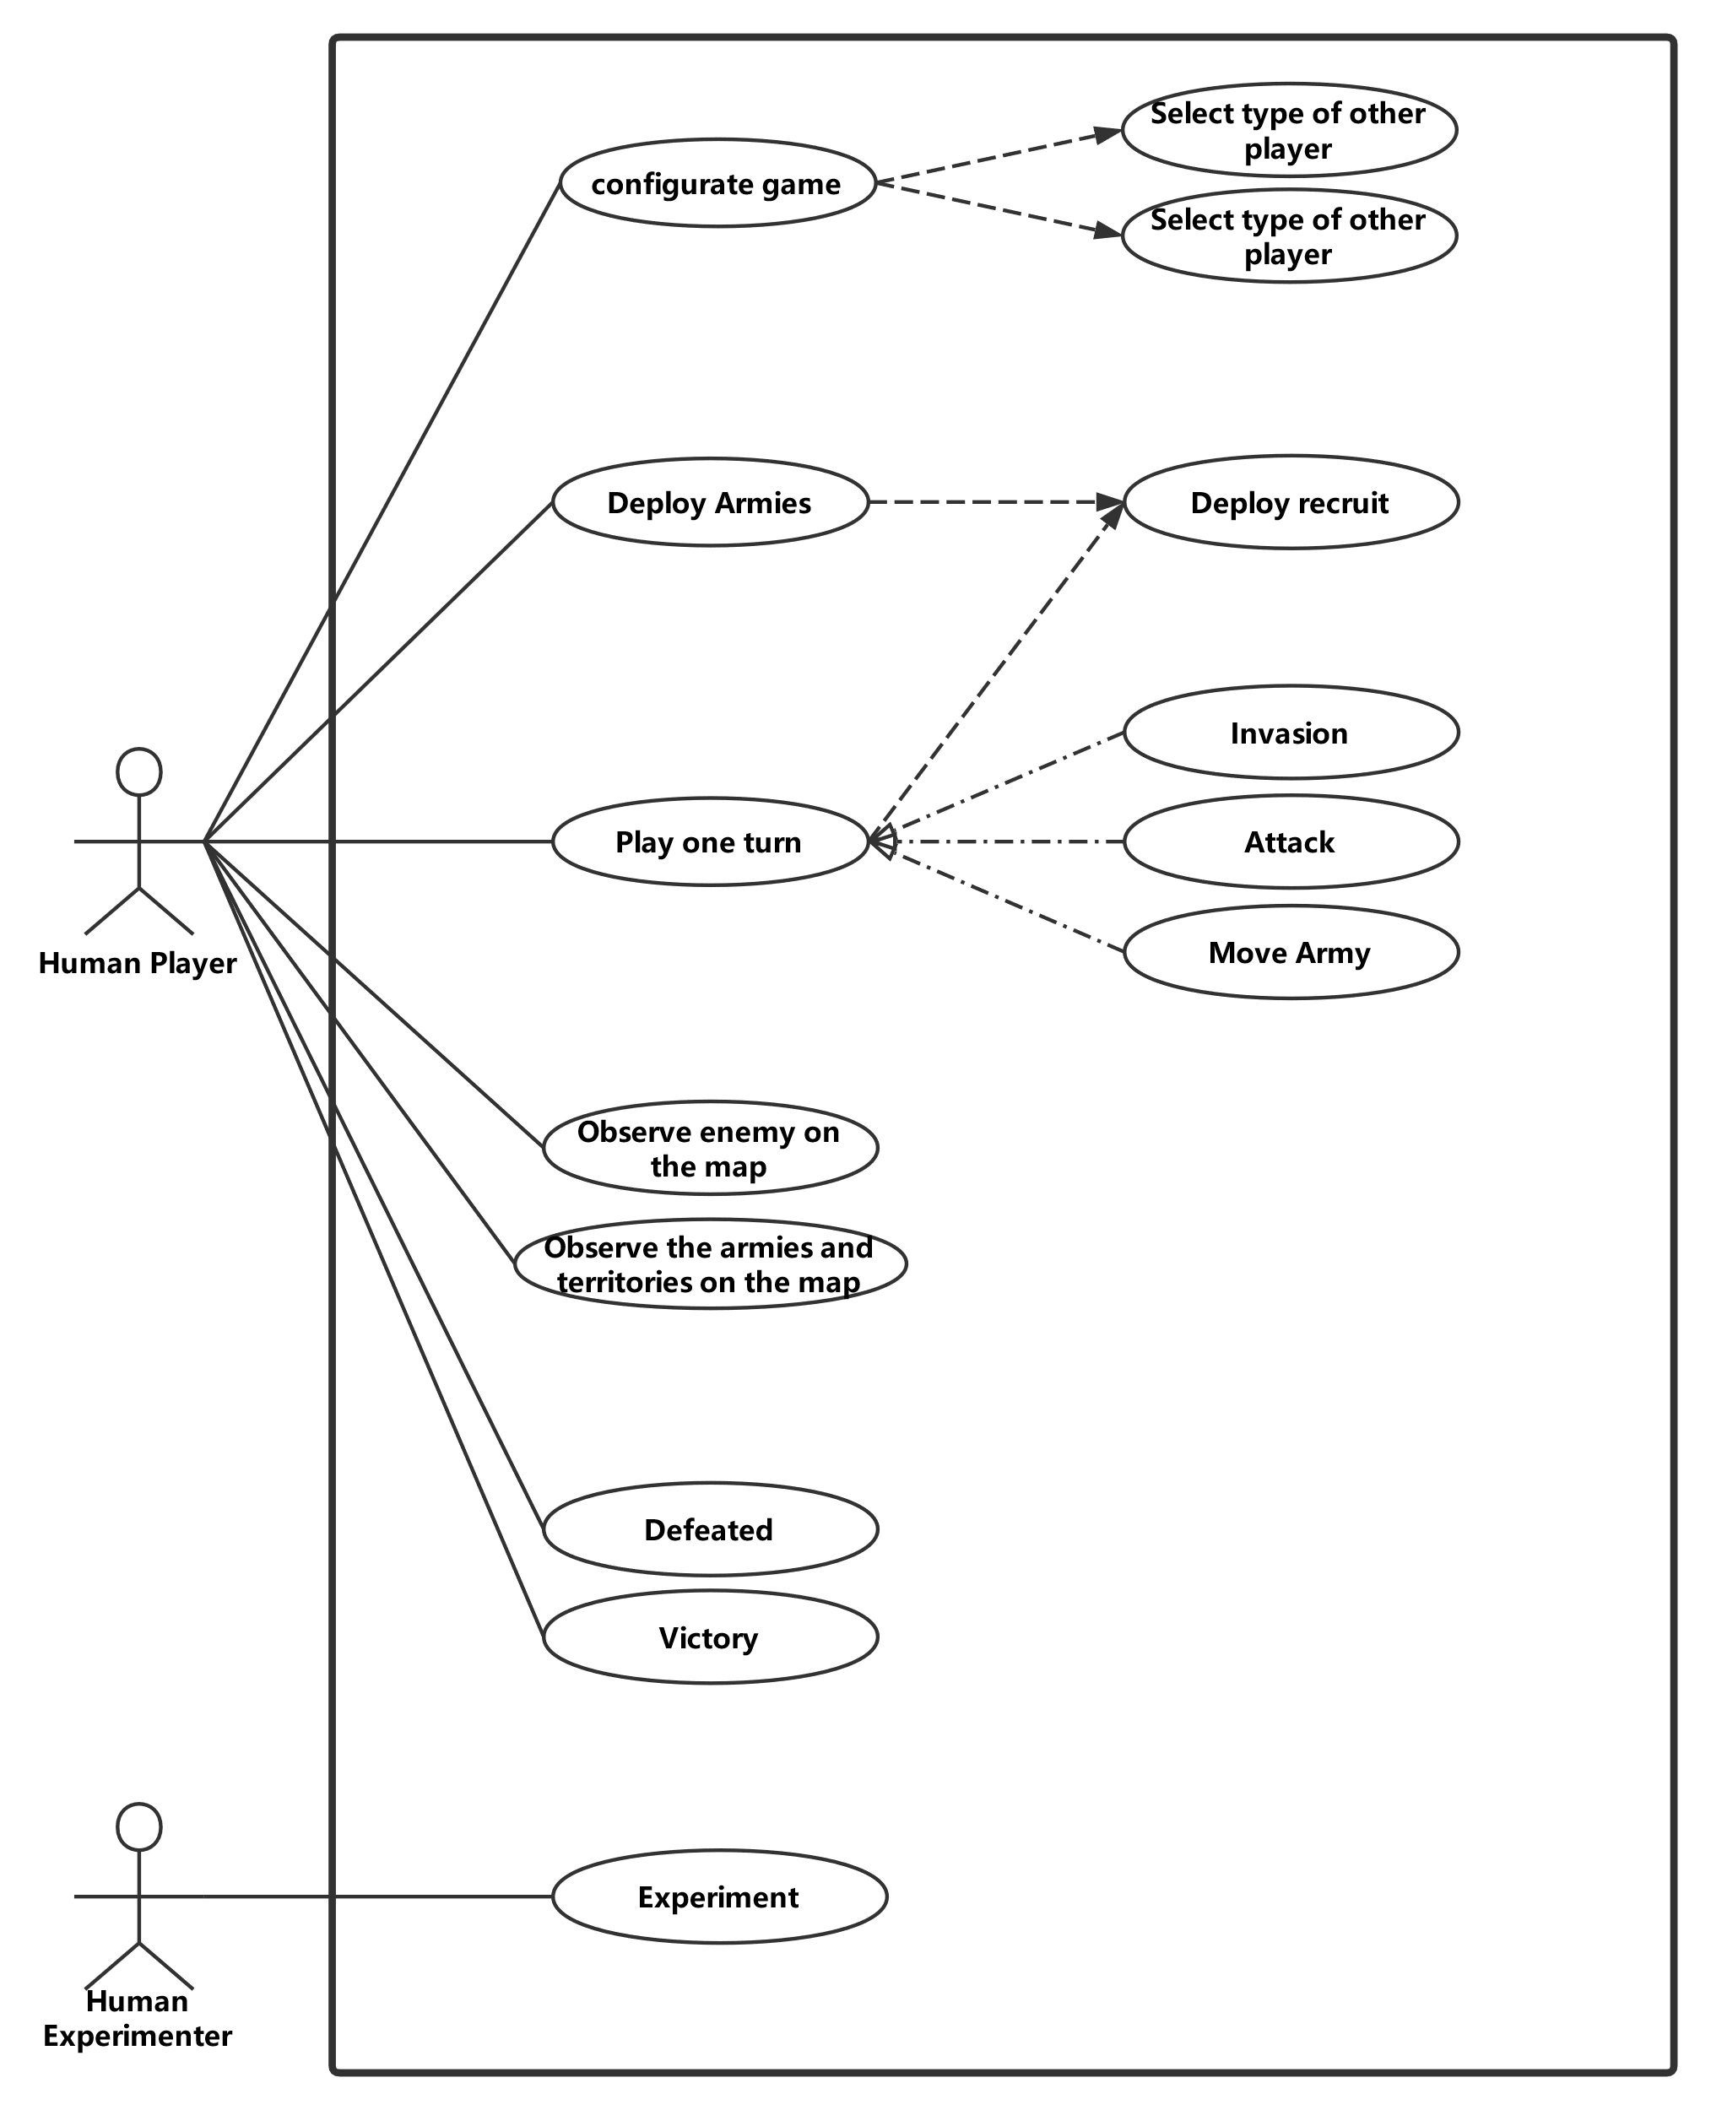

Figure 1 Use case Diagram

|  |  |
| --- | --- |
| **ID** | UC1 |
| **Name** | Configure game |
| **Description** | The user configures the game before starting a new game. |
| **Pre-conditions** | There is not any information about the number and the type of player. |
| **Event flow** | The game system shows the user a guide of configuration. include UC2() include UC3() Generate the game based on the data from UC1 and UC2 |
| **Post-condition** | The game has been generated according to the collected data. |
| **Includes** | UC2, UC3 |
| **Extensions** | None |
| **Triggers** | A game user click button “Start Game” |

|  |  |
| --- | --- |
| **ID** | UC2 |
| **Name** | Input number of the player |
| **Description** | The user inputs the number of the game player. |
| **Pre-conditions** | The system doesn’t know the number of players. |
| **Event flow** | At first, the game system requires the number of players from the user. After the user types a number, the system will check the validation. **if** it is valid,   the system will store the number of the player. **else**  the system will notify the user, the number is invalid. |
| **Post-condition** | The number of the player has been stored in the system. |
| **Includes** | None |
| **Extensions** | None |
| **Triggers** | A game user click button “Start Game” |

|  |  |
| --- | --- |
| **ID** | UC3 |
| **Name** | Select type of other players |
| **Description** | The user selects the type of another player in the game. |
| **Pre-conditions** | The system doesn’t store any information about other players  The system has stored the number of players. |
| **Event flow** | **for** all other players,  the user selects the player type from (human, simpleAI, normalAI, HardAI).  and then, it will be recorded in the system |
| **Post-condition** | The system has recorded the type of all players. |
| **Includes** | None |
| **Extensions** | None |
| **Triggers** | UC2 has been finished. |

|  |  |
| --- | --- |
| **ID** | UC4 |
| **Name** | Deploy Armies |
| **Description** | The human player deploys its armies at the start of the game. |
| **Pre-conditions** | A player doesn’t deploy the armies and the game is still in the configuration phase. |
| **Event flow** | **for** each recruit in the configuration phase  include UC5() |
| **Post-condition** | The player doesn’t have undeployed armies. |
| **Includes** | UC5 |
| **Extensions** | None |
| **Triggers** | The configuration turn of the player starts. |

|  |  |
| --- | --- |
| **ID** | UC5 |
| **Name** | Deploy recruit |
| **Description** | A human player deploys its recruit on the map. |
| **Pre-conditions** | The player has an undeployed recruit and in the recruiting phase. |
| **Event flow** | select a province on the map **if** it has already been occupied by the player,  the number of the armies on the province plus one. **if** it has already been occupied by another player,  abort the deployment. **if** it is unoccupied,  allocate the province to the player   set the number of armies on the province to be one. |
| **Post-condition** | The size of the player’s armies plus one. |
| **Includes** | None |
| **Extensions** | None |
| **Triggers** | The player clicks the allocate button. |

|  |  |
| --- | --- |
| **ID** | UC6 |
| **Name** | Invasion |
| **Description** | A human player’s armies invade the other player’s territory. |
| **Pre-conditions** | One of the player’s armies is on the boundary and in the attack phase. |
| **Event flow** | The user selects an army on the boundary. After that, move the army into an enemy’s province which is ungarrisoned Then, the player occupies the province. |
| **Post-condition** | The number of the player’s provinces plus one |
| **Includes** | None |
| **Extensions** | None |
| **Triggers** | The player drags an army on the belligerent’s ungarrisoned province |

|  |  |
| --- | --- |
| **ID** | UC7 |
| **Name** | Attack |
| **Description** | A human player’s one of the armies attacks the enemy and in the attack phase. |
| **Pre-conditions** | One of the player’s armies is nearby the enemy. |
| **Event flow** | The user selects an army on the boundary. After that, move the army into an enemy’s province which is garrisoned Then, the system calculates the result of the battle The armies of the defeated party will be annihilated The province will be occupied by the winner. |
| **Post-condition** | One of the belligerents’ armies on the province is annihilated |
| **Includes** | None |
| **Extensions** | None |
| **Triggers** | The player drags an army on the belligerent’s garrisoned province |

|  |  |
| --- | --- |
| **ID** | UC8 |
| **Name** | Move Army |
| **Description** | A human player moves the army between own provinces. |
| **Pre-conditions** | The number of the army of the player is not zero and the player is in the attack phase |
| **Event flow** | The user selects an army. After that, move the army into its own province Then, the number of garrisons plus one. |
| **Post-condition** | The allocation of the player’s armies is changed |
| **Includes** | None |
| **Extensions** | None |
| **Triggers** | The player drags an army on the belligerent’s garrisoned province |

|  |  |
| --- | --- |
| **ID** | UC9 |
| **Name** | Play one turn |
| **Description** | A human player plays one turn of the game. |
| **Pre-conditions** | The player doesn’t be defeated. |
| **Event flow** | The game turn starts. the player enters the Deploy Phase,  **for** each recruit do  include to UC5(); **for** each army in the map do  **if** the user decides to invade  include to UC6();  **if** the user decides to attack  include to UC7();  **if** the user decides to move  include to UC8(); end the game turn |
| **Post-condition** | The player ends the turn. |
| **Includes** | None |
| **Extensions** | UC5, UC6, UC7, UC8 |
| **Triggers** | The player turn starts. |

|  |  |
| --- | --- |
| **ID** | UC10 |
| **Name** | Observe enemy on the map |
| **Description** | A human player observes the location and the number of armies or provinces of other players. |
| **Pre-conditions** | The player currently doesn’t be defeated. |
| **Event flow** | Observe provinces and armies on the map. |
| **Post-condition** | The player has observed the enemy. |
| **Includes** | None |
| **Extensions** | None |
| **Triggers** | The player is going to observe the enemy. |

|  |  |
| --- | --- |
| **ID** | UC11 |
| **Name** | Observe own armies and provinces |
| **Description** | A human player observes the location and the number of own armies or provinces. |
| **Pre-conditions** | The player currently doesn’t be defeated. |
| **Event flow** | Observe provinces and armies on the map. |
| **Post-condition** | The player has observed own armies and province. |
| **Includes** | None |
| **Extensions** | None |
| **Triggers** | The player is going to observe own armies and provinces. |

|  |  |
| --- | --- |
| **ID** | UC11 |
| **Name** | Victory |
| **Description** | A human player wins the game. |
| **Pre-conditions** | The player is the last player of the game. |
| **Event flow** | The game system finds that the player is the last player of the game. After that, the system shows a notification to the player. |
| **Post-condition** | The game is over, or the player is removed from the game. |
| **Includes** | None |
| **Extensions** | None |
| **Triggers** | UC2 require remotely authenticated service |

|  |  |
| --- | --- |
| **ID** | UC12 |
| **Name** | Defeated |
| **Description** | A human player is defeated. |
| **Pre-conditions** | The number of the player’s armies and provinces is zero. |
| **Event flow** | The player’s last province has been occupied by an enemy. The system checks the number of human players. **if** the number is zero,  Game over and conclude the result of the game; **else  the** game continues,  but the player will be removed from the game; |
| **Post-condition** | The game is over, or the player is removed from the game. |
| **Includes** | None |
| **Extensions** | None |
| **Triggers** | UC2 require remotely authenticated service |

|  |  |
| --- | --- |
| **ID** | UC13 |
| **Name** | Experiment |
| **Description** | A human experimenter to exam the AI system. |
| **Pre-conditions** | The game system is running. |
| **Event flow** | The experimenter clicks the “Simulating” button on the main menu.  The experimenter decides types of two computer players. The system automatically generates and logs the result of the game. |
| **Post-condition** | The game is over, and the game log has been produced. |
| **Includes** | None |
| **Extensions** | None |
| **Triggers** | The experimenter clicks the “Simulating” button on the main menu. |

**4.2** **Architecture Design**

下图显示了游戏程序的子系统上下文模型。很明显，游戏程序的体系结构模式是 “Model-View-Controller”.

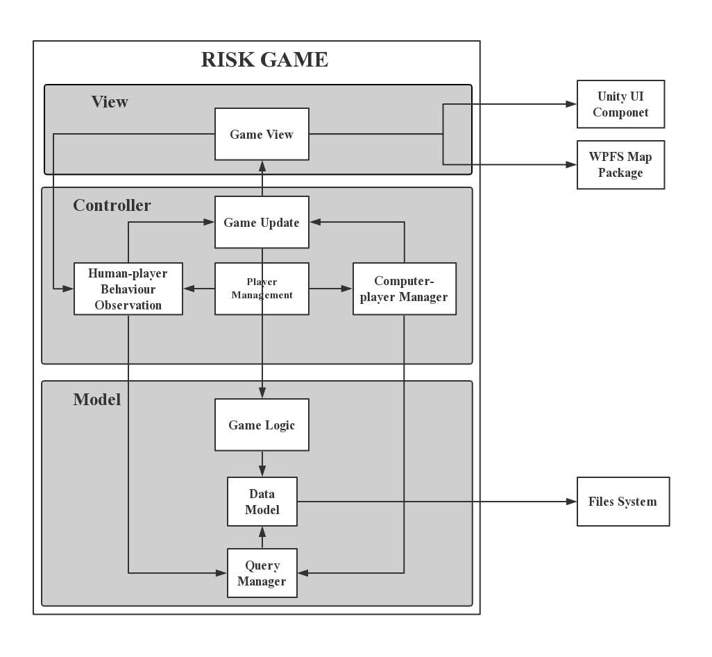

Figure 2 Context Model of 战国风云

### **4.2.1 View**

在游戏视图中，一个名为 WPFS 的包和另一个名为 Unity GUI的包用于实现用户界面。这些外部 API 降低了项目开发的复杂性，但降低了游戏核心的可移植性。因此，游戏视图被设计为一组封装类，用于包装外部 API 来解决问题。

### **4.2.2 Model**

模型部分管理可能的数据 I/O 并维护数据模型，例如不同区域、大陆、玩家军队和领土之间的关系等。它还实现了有关游戏逻辑的所有算法。它包括"游戏逻辑系统"、"查询管理系统"和"数据模型系统"。

### **4.2.3 Controller**

控制器被设计为游戏模型和游戏视图之间的通信媒介。在游戏程序中，它负责将游戏回合分配给每个玩家，监控人类玩家的行为并更新游戏视图。它包括"游戏更新系统"、"人类玩家行为观察系统"、"计算机玩家AI系统"和"玩家管理系统"

**4.3 Abstract Specification**

### **4.3.1 Subsystem in View**

"游戏视图系统"是游戏视图中的一个子系统，它分装了引用游戏地图和用户界面的外部 API。具体来说，它处理地图颜色.

总体而言，"游戏视图系统"是外部 API 的封装，指的是游戏地图和用户界面。具体而言，子系统包装Unity GUI 和 WPFS 包的方法，以便它提供用于更新游戏接口的集函数。此外，它可以接收用户行为，如移动鼠标，单击按钮或地图上的区域，并通过事件向人类行为观察系统发送消息。

### **4.3.2 Subsystem in Controller**

"人类玩家交互系统"解释人玩家在游戏中的可能行为。此子系统将"游戏视图系统"中的消息与"数据查询系统"的信息转换为"游戏更新系统"的各种说明，并分别更新游戏视图和游戏模型。

"计算机玩家AI系统"是游戏AI的实现。此子系统由游戏中的所有计算机玩家组成。它能够从"数据查询系统"为游戏构建一个确认模型，然后为计算机玩家生成策略，并将策略交付给"游戏更新系统"。

"玩家管理系统"既控制"人机交互系统"，又控制"计算机玩家AI系统"。子系统的职责是决定当前游戏属于哪个玩家。

"游戏更新系统"通过"游戏视图系统"和"游戏逻辑系统"之间的通信，接受人和计算机玩家的指导，以更新游戏视图和模型。

### **4.3.3 Subsystem in Model**

"游戏逻辑系统"在游戏模型中实现所有游戏逻辑。玩家的攻击、移动和强化等动作的结果将在子系统中计算。它将接收来自"游戏更新系统"的消息，并直接更新"数据模型系统"。

"查询管理系统"为"人机交互系统"和"计算机玩家AI系统"提供了一组API，用于查询"数据模型系统"中的数据存储。该设计减少了控制器和模型之间的耦合。

"数据模型系统"是游戏数据的核心，因为有关游戏的所有数据都存储在子系统中，例如每个区域的邻域、玩家的军队和领地等。它直接与文件系统通信，以写入或读取游戏记录。

**4.4 Interface Design**

在本部分中，本文档将描述游戏用户界面的设计。游戏的用户界面由两部分组成，即地图板和功能组件。

### **4.4.1 Map Board**

游戏地图应清楚地显示各大洲、每个区域、玩家的领地和军队。下图3显示了游戏地图的设计：游戏开始时，不同的大陆被不同的颜色覆盖，并且每个区域将显示当地军队的数量。此外，不同的玩家区域将被不同的颜色覆盖。



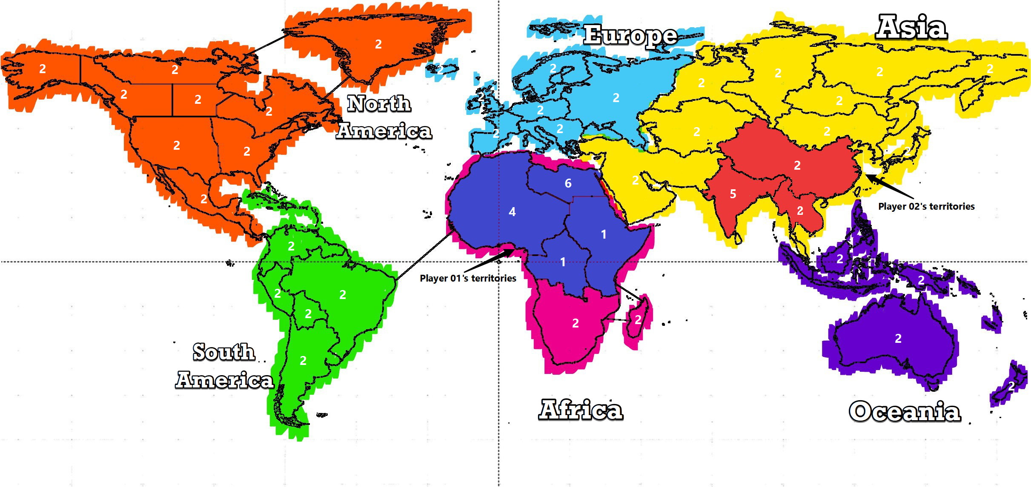

Figure 3 Game Map Design

### **4.4.1 Functional Components**

功能组件为人类玩家提供不同的功能。如图 4 所示，功能组件将由顶栏、历史面板和玩家信息面板组成。

* 顶部栏包括屏幕顶部的四个按钮和三个文本字段。从左到右，两个文本字段分别显示当前转弯数和当前转弯的阶段。左侧的两个按钮允许当前人类玩家放置她/他的新兵或攻击附近的区域，其余两个按钮允许人类玩家结束她/他回合或退出游戏。
* 历史面板在游戏屏幕底部垂直对齐。每个玩家的操作都会被记录，然后在面板中列出。此外，面板顶部有一个按钮，可以隐藏其全部内容。
* 玩家信息面板在屏幕右侧以层次结构对齐。它显示所有玩家的代表颜色，姓名和招募人数在每一个回合。

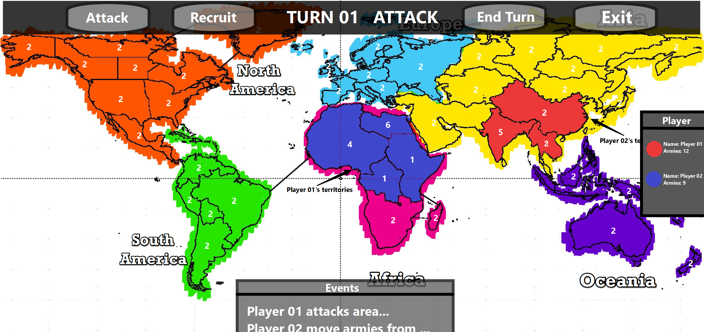

Figure 4 game interface design

**4.5 Components Design**

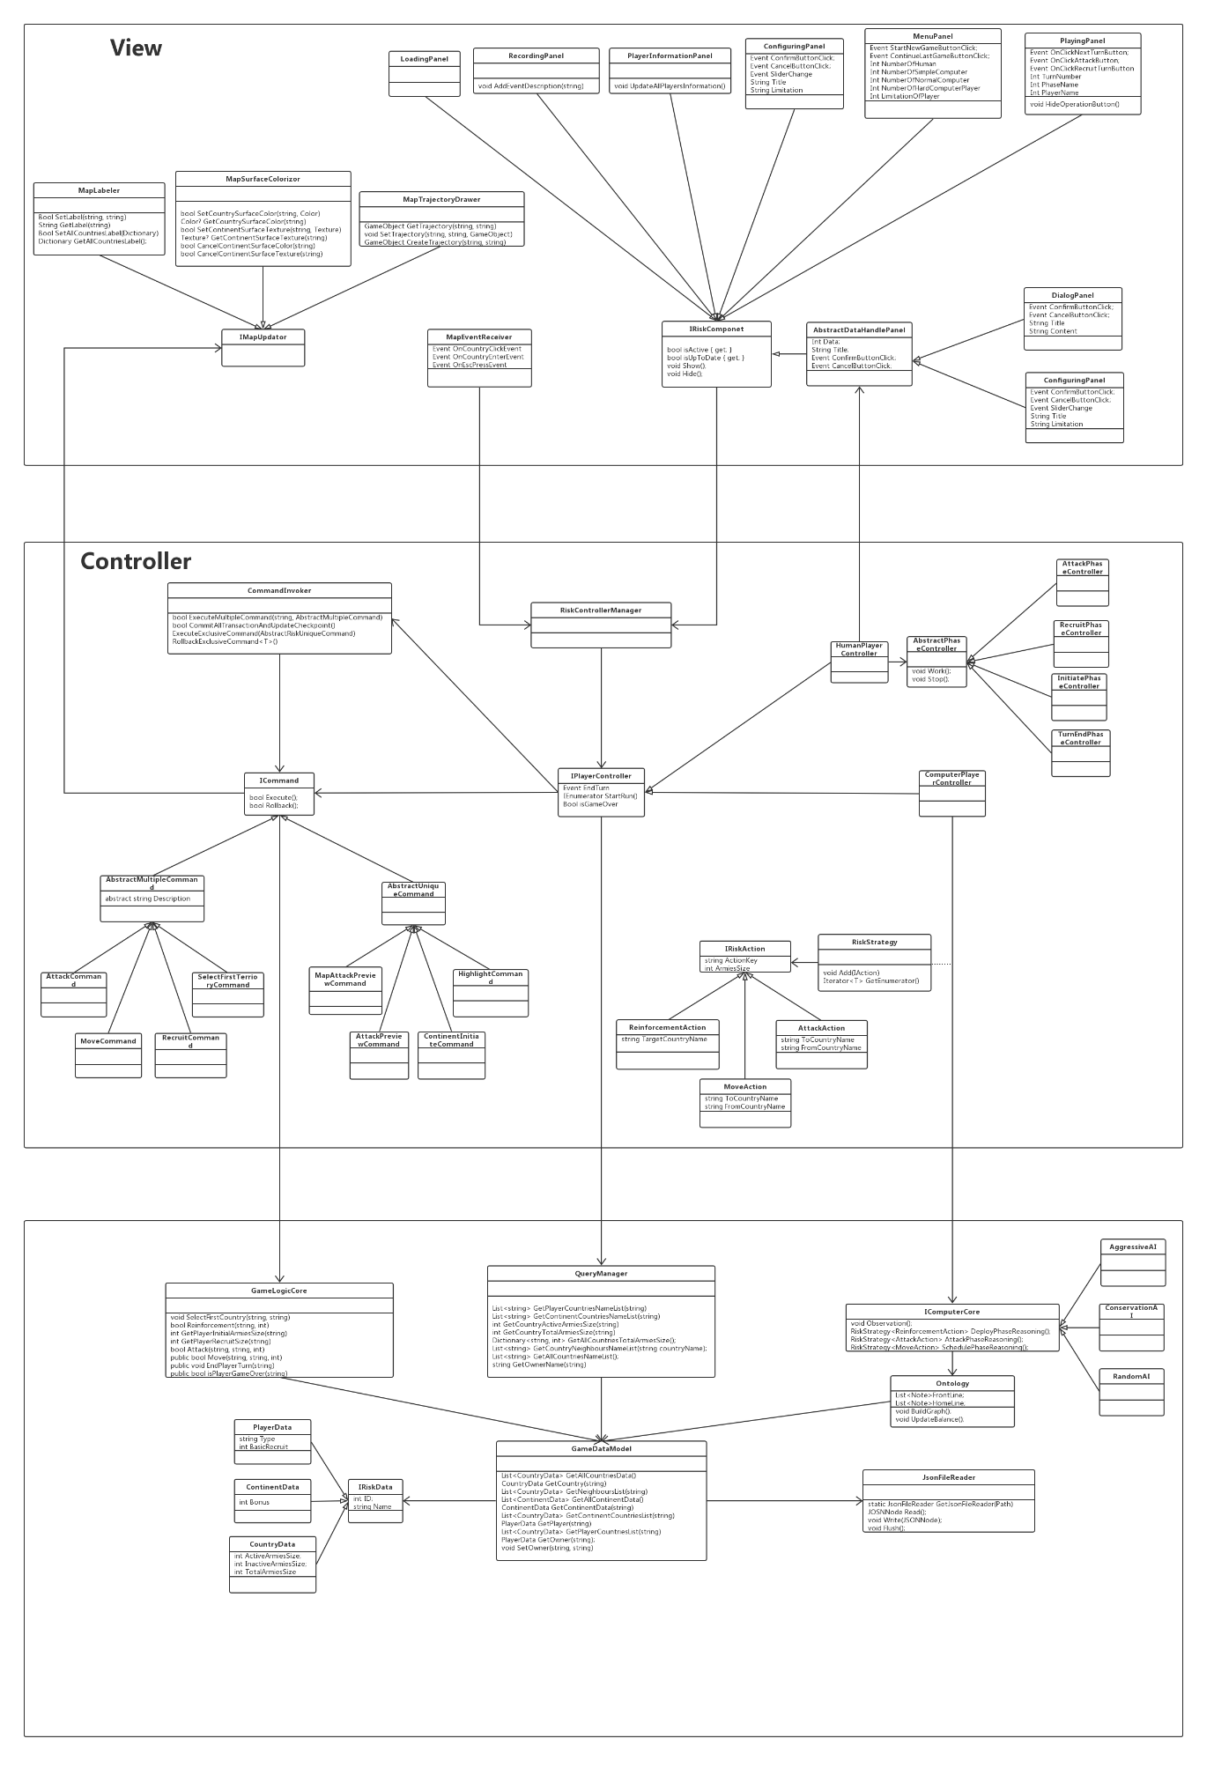

Figure 5 The class diagram

### **4.5.1 Classes in View**

在游戏程序中，视图由 Unity GUI 组件和 WFPS 映射包的一组封装组成。

在 WFPS 地图中，"地图区域标注器"、"地图表面绘制器"和"地图轨迹绘制器"这三个Class提供将在控制器中使用的函数："地图区域标注器"分装 API，用于更改地图上每个区域的标签和图标;"MapSurfaceDrawer"允许控制器使用颜色或纹理对特定区域的表面着色，而"MapLandlDrawer"提供在任意两个区域之间绘制线条的功能。此外，Class"MapEventReceiver"监视人类玩家的所有可能操作，并生成匹配事件，然后将它们发送到正确的位置。

关于 Unity GUI，它们是一组在 Unity 引擎中附加的预定义函数，用于接收和响应用户的行为。Class为游戏视图中的特定组件包装一组 Unity GUI 函数，它提供了一种操作该组件的方法。游戏视图中共有 8 个Class，它们操作 8 个不同的 UI 组件。这八个Class是"加载面板"、"历史面板"、"玩家信息面板"、"配置面板"、"菜单面板"、"游戏面板"、"对话框面板"和"配置面板"。此外，名为"IRiskComponent"的接口指定这些Class的操作。

### **4.5.2 Classes in Controller**

在控制器部分中，从视图部件生成的事件将传递到匹配的玩家控制器，名为"控制器管理器"的Class管理所有这些玩家控制器。它还处理如何分配玩家的游戏回合，因为每个玩家控制器将处理从游戏视图接收的事件或更新游戏视图，仅玩家自己的游戏回合。

"人类玩家控制器"处理人类玩家的动作，它由一组阶段控制器组成，因为游戏程序需要对不同游戏阶段的相同动作做出不同的反应。有一个名为"抽象阶段制器"的抽象Class，它控制一个游戏的阶段，有四个Class实现这个抽象Class，即"Intiate阶段控制器"、"招募阶段制器"、"攻击阶段制器"和"转端阶段控制器"。这些Class由人工控制器控制，并在玩家选择第一个区域时从视图中处理事件;部署新兵;攻击其他玩家的领土或结束她/他当前的游戏回合。

"计算机玩家控制器"基于当前条件对策略进行原因，并依次执行它。计算机玩家依靠 AI 核心在每一回合生成其策略，而 AI 内核的效率决定了计算机玩家属于哪个级别。然而，AI核心是游戏模型的一部分，推理只能在游戏模型中产生。推理结果将存储在"=策略"中，然后发送给计算机玩家。"Strategy"是"Action"的容器，包括对计算机玩家的指令。"IAction"是接口，它由"强化行动"、"移动行动"和"攻击行动"实现。

为了减少更新游戏模式和视图的可能代码重复，在游戏程序中引入了命令系统。游戏和视图的所有更新都通过Class"命令调用器"和一组特定命令实现。Class"命令调用器"将执行收到的所有命令，命令将包装更新所需的所有操作。接口"ICommand"描述了命令的公共接口，此外，还有两种不同的命令，即"抽象多路命令"和"抽象唯一命令"。"抽象调遣命令"描述命令的常见函数，该函数在游戏中可以存在复数实例。但是，扩展"抽象唯一命令"的Class在游戏中只能有一个实例，并且前一个实例（如果存在）将滚动备份。Class"攻击命令"、"移动命令"、"招募命令"和"选择第一区域命令"实现"抽象多路命令"，Class"地图攻击预览命令"、"区域突出显示命令"、"大陆启动命令"和"大陆启动命令"和"区域启动命令"Class。映射启动命令"实现"抽象唯一命令"。

### **4.5.3 Classes in Model**

游戏程序的模型部分需要从本地文件中读取数据，以构建一个游戏数据模型，该模型存储数据，如不同区域的地理关系、每个玩家的领土和军队等。

"QueryManager"从控制器部件接收查询，然后从游戏模型搜索可能的结果，然后它会以尽可能精确的数据回复这些查询。它允许查询有关特定区域、特定玩家或某个区域的所有区域的所有者的军队规模和所有者的数据。

与"查询管理器"相比，"GameLogicCore"在收到来自控制器部件的消息后不会生成任何返回值，因为它只会更改数据模型中的数据。它提供了计算战斗结果和每个玩家招募大小的函数。

"GameDataModel"存储与游戏相关的所有数据，包括"玩家数据"、"大陆数据"和"CoutryData"，并且它还存储这些数据之间的关系。抽象Class"IData"指定这些数据的字符。"PlayerData"Class记录玩家的信息，如她的ID、姓名、军队和领土的大小。"大陆数据"Class表示地图上的指定区域。该Class包括大陆的名称，当一个玩家占领大陆时的人力奖励。"区域数据"Class表示游戏的最小地理单位。记录其附近地区名称的列表、每个回合生成的新兵人数以及某一地区的军队规模。

"IComputerCore"是AI内核的接口，为计算机玩家生成策略。为了产生一种策略，计算机玩家核心将首先收集当前状况的信息，然后根据收集到的信息生成一组加强、攻击和计划军队的行动，然后产生一个策略。"随机AI"、"攻击性AI"和"消极AI"分别实现"IComputerCore"Class。

在 AI 内核收集有关当前状态的足够信息后，将创建"计算机玩家逻辑核心"的实例。它建立玩家领地的拓扑结构，并计算与敌人领土相邻的地区军队数量不足。

## **4.6 AI Activity Diagram**

在每个玩家的游戏回合中，玩家首先部署他们的新兵，然后攻击敌人，然后移动军队来巩固她/他的领地的前线。因此，AI 玩家将能够通过其推理生成所有这些操作。此外，它还应该能够观察环境（游戏板）的当前状况，这些条件提供足够的信息来执行推理。下面的序列图说明了消息如何在计算机玩家控制器和模型之间交换以生成这些操作。

在推理之前，计算机玩家控制器（控制器部分）将要求计算机玩家核心（在模型部分）观察游戏板以收集其领土、军队规模和敌人等信息。然后，计算机玩家核心将构成一个基于观察信息的"本体"。之后，将生成一个策略，包括一系列操作，并将其传递到计算机玩家控制器。最后，控制器将在策略中执行所有操作。

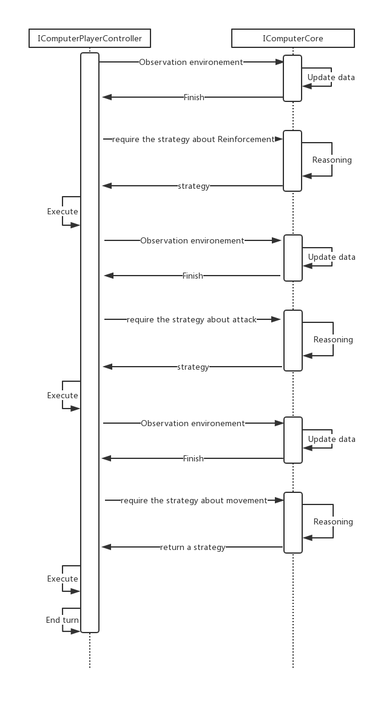

Figure 3 Sequence Diagram for Computer player controller and model

**4.7 Data structure Design**

### **4.7.1 RelationMatrix**

The “RelationMatrix” is an implementation for the matrix with only entries from the Boolean domain {0,1} namely, relation matrix or binary matrix[17][18]. The pseudocode below describes possible functions and members in the “RelationMatrix”. The two dimensions byte array named “matrixCore” stores the value in each row and column of the matrix, in addition, two functions “SetRelation” and “GetRelation” allows to read and write these values.

class RelationMatrix {

byte[][] matrixCore

void SetRelation(int row, int column, bool value){

matrixCore[row][column] := value? 1:0

}

bool GetRelation(int row, int column){

return matrixCore[row][column]

}

}

Pseudocode 01: the pseudocode of the relation matrix

The class stores the binary relation between different game model data. In the project, the class is used as an adjacency matrix to record the neighbour-relation between two areas on the map. In addition, it also records the ownership between player and area, and the relation between area and continent.

### **4.7.2 PriorityOrderedList**

The “PriorityOrderedList” is a container class and all elements stored in the class will be sorted by a predefined integer parameter named priority. Therefore, the larger the priority is, the more front the element is in.

The pseudocode below describes possible functions and members in “PriorityOrderedList”. The List “listCore” stores all items and their priority. The function “Add” allows inserting a new item into the container and “GetElement” provides a method to retrieve data in there.

class PriorityOrderedList<T> {

List<(T, int)> listCore;

void Add(T newElement, int atPriority){

Use binary search to find out index of the element;

listCore.Insert(index, (newElement, atPriority));

}

T GetElement(int atPriority){

Use binary search to find out index of the element;

return listCore[index]

}

}

Pseudocode 02: the pseudocode of PriorityOrderList

In the class “MapSurfacePainter”, the colour on each area’s surface may alter at some condition, and then recover back to the previous colour. Therefore, it requires the class “MapSurfacePainter” to record the colours which were on each area surface. The “PriorityOrderedList” provides a method to implement the requirement and reduces the complexity of “MapSurfacePainter”.

### **4.7.3 GameStrategy**

The class “GameStrategy” is the container for the message between the AI core and computer player controller. The similar actions stored in the class will be merged.

The pseudocode below describes possible functions and members in class “GameStrategy”. All actions are stored in the list “strategyCore”. In addition, the class only provides the method “Add” to add new actions and method “GetEnumerator” to implement the Iterable interface.

class RiskStrategy<T>: IEnumerable<T> where T:IRiskAction

List<T> strategyCore;

void Add(T newAction){

compares with each other actions;

if find any similar action,

mergeing the two actions;

else

strategyCore.Add(newAction);

}

IEnumerator<T> GetEnumerator() {

return strategyCore.Values.GetEnumerator();

}

}

Pseudocode 02: the pseudocode of PriorityOrderList

### **4.7.4 BalanceGraph and BalanceNode**

The class “BalanceGraph” and “BalanceNode” are implementation for an abstract data structure named. “Undirected Graph” [19] and its node.

The diagram below describes a model of the data structure, “BalanceGraph”. In the diagram, circles and edges express instances of “BalanceNode” and neighbour-relations between these nodes. In addition, the number on nodes means the depth of a node which is called “Level” in the class. To constitute a balance-graph, the shallowest nodes (whose level equal 0) shall be predefined and the levels of other nodes shall equal to the smallest number in neighbours’ level plus one. In addition, a special algorithm will calculate the balance for each node. These nodes and edges consist of a balance graph.

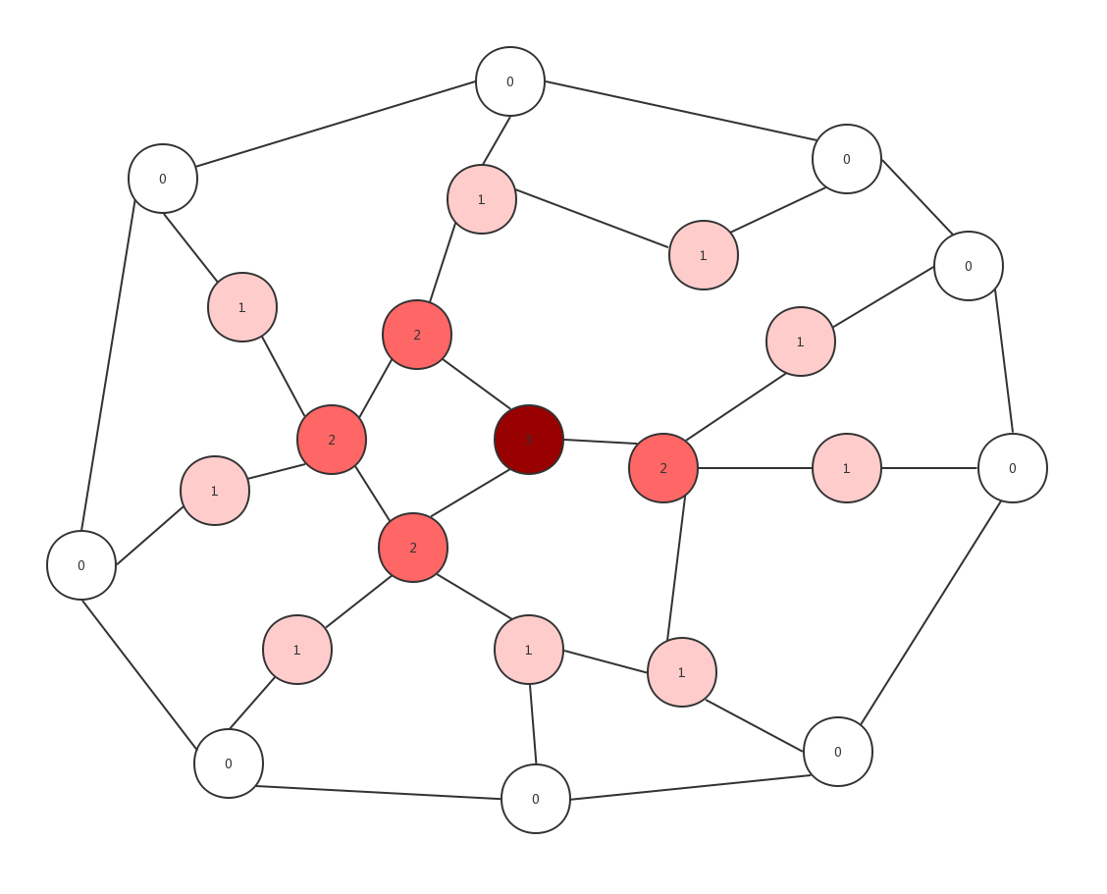

Figure 4 Example of BalanceGraph

In the project, this data structure is used to store the essential data in AI core such as the computer player’s territories and enemies. In addition, a distributed algorithm is implemented in the data structure, which will calculate the size of armies each node required for fortifying.

The pseudocode below describes public functions and members in two classes. The “shallowestNodeList” is used to store the nodes whose level equal 0. The function “UpdateBalance” shall calculate the balance for each node through a predefined algorithm and “GetBalance” shall return the balance value of a specified node. In addition, “Get” and “Add” provide an interface to write an read the data store in the graph.

class BalanceGraph<T> where T:IRiskData {

List<BalanceNode<T>> shallowestNodeList;

bool UpdateBalance(){…}

int GetBalance(T ofItem){…}

List<T> Get(int atlevel){…}

void Add(T Item, List<T> neighbourList){…}

private class BalanceNode<T> where T:IRiskData {

int CurrentLevel { get; private set; }

int Balance { get; private set; }

T dataCore { get; }

List<BalanceNode<T>> NeighbourNodes

}

}

Pseudocode 03: the pseudocode of Balance Graph

**4.8 Algorithm Design**

### **4.8.1 Binary Searching**

In the data structure “PriorityOrderedList”, it is essential to traverse the whole list in some methods. Because the data stored in “PriorityOrderedList” are sorted by their predefined priority, the binary searching algorithm can be used to reduce the complexity of some operations in the data structure.

function binary_search(A, n, T):

L: = 0

R: = n

while L < R:

m: = floor((L + R) / 2)

if A[m] <= T:

L: = m + 1

else :

R: = m

return L - 1

Pseudocode 04: the pseudocode for Binary Search [19]

### **4.8.2** **FloodMin Algorithm**

In the project, the FloodMin algorithm is used to build or update the data structure “BalanceGraph”. The design and implementation of the FloodMin algorithm based on the FloodMax algorithm introduced on Module COMP212 Distributed system.

var myLevel := max_int; // node current level   
var receiveLevels := new List<Level>   
var diameter := diameter of the graph  
if (round = 1) then  
 send own level to all neighbours;  
else  
 receiveLevels := receiving levels from neighbours;  
if max(receiveLevels) < myLevel - 1   
 myLevel := max(receiveLevels) - 1  
 newInfo := true  
else   
 newInfo := false  
if round ≤ diameter and newInfoi = true then  
 send myLevel to all neighbours  
else if round = diameter + 1 then   
 return;

Pseudocode 05: the pseudocode of FloodMin [5]

### **4.8.3 Balance Calculating Algorithm**

The Balance Calculation algorithm is used to estimate the size of armies for each territory required to fortify, which are called balance in the project. In both reinforcement and fortification stage, the AI core will generate the best strategies based on these data.

foreach node whose level equal 0

node.Balance := area.armiesSize;

foreach nearby enemies’ territory

node.Balance -= the size of armies on nearby enemy territory;

foreach exist level in the player’s territories

foreach node whose level equal current Level  
 node.Balance := area.armiesSize;

foreach neighbour node whose level is less than current Level

if neighbourNode.Balance < 0  
 node.Balance -= neighbourNode.Balance;

Pseudocode 06: the pseudocode of Balance Calculating Algorithm

**4.9 Test Design**

As described in the specification document, the project will use the object-oriented testing to test the program and will strictly follow a top-down integrate testing process, namely, operation test, class test, cluster test, system test.

### **4.9.1 System Test Design**

At first, the system test shall check the integration of the whole system. The black-box test will be used to implement the system test. Specifically, it shall include tests below:

Set the number and type of computer game player;

Click different game map areas;

Deploys recruits;

Attack others player’s territory;

Move armies in test player’s territories.

Check scenes for winning or losing the game

### **4.9.2 Cluster Test**

Second, the cluster test shall check the message communication between different game components. In the project, the test can be done through the Unity Debug package, which provides a set of functions to check variables in the game program. In addition, it shall include tests below:

Check the communication between the game view and game controller;

Check the communication between the game controller and game model;

### **4.9.3 Unit Test**

In the class and operation test, the public fields of the critical classes will be tested. Unit Test tool for the C#, NUnit will be used to test methods provided in the class map painter, map labeler, map trajectory maker and the game model. Because almost all controllers directly communicate with both game view and game model, there is not a class test and operation test on the game controller. Specially, it shall include:

Check the correction of the data stored in the 战国风云DataModel;

Check the functions in the 战国风云DataModel;

Check the functions in MapSurfacePainter;

Check the functions in MapTrajectoryMaker;

Check the functions in MapLabeler.

**4.10 Evaluation Design**

### **4.10.1 Self-evaluation**

In the project, the programmer will be required to evaluate the game quality by “functional points”. In the function point evaluation, the game will be divided into a series of functions in different aspects and each aspect will be allocated a weight. The programmer needs to count the number of finished requirements in different aspects to calculate the final value of the game. Table 02 below describes different aspects of function point and their weight.

|  |  |  |  |  |  |  |  |
| --- | --- | --- | --- | --- | --- | --- | --- |
| **Function** | **Simple** | | **Normal** | | **Hard** | | **Total** |
| **Point** | **Num** | **Point** | **Num** | **Point** | **Num** |
| Game logic | 2 |  | 3 |  | 5 |  |  |
| User interface | 1 |  | 2 |  | 3 |  |  |
| Game Controller | 2 |  | 3 |  | 4 |  |  |
| Artificial Intelligence | 3 |  | 5 |  | 8 |  |  |

*Table 01: The table for the function points*

The game logic, user interface, game controller and artificial system respectively represent the function in the game model, game controller and the artificial intelligence system. The simple, normal and hard represent the complexity of these function.

Additionally, the programmer will use the functional and non-functional requirements as the criteria to compare the 战国风云 game online such as Polo战国风云 and WarGame战国风云.

|  |  |  |  |
| --- | --- | --- | --- |
| **Function** | **Marks (0 ~ 5)** | | |
| **The project** | **Warzone** | **Polo战国风云** |
| Is the game online available? |  |  |  |
| Is there a visual user interface? |  |  |  |
| Can the player attack an enemy? |  |  |  |
| Can the player move the army? |  |  |  |
| Can the player deploy recruit? |  |  |  |
| Does the game provide multiple game model? |  |  |  |
| Does the game provide different kinds of computer player? |  |  |  |

*Table 02: The table for the criteria*

### **4.10.2 3rd party Evaluation**

In this part, the project will design a survey to collect feedback from the player. In addition, the project will strictly follow the requirements in the “Computer Science Student project 3rd party Evaluation Procedure” [5]

|  |  |
| --- | --- |
| Questionnaire | Marks (-5~5) |
| How likely is it that you would play this game on your computer or smartphone? |  |
| Is the game user-friendly? |  |
| Is the UI well-designed? |  |

*Table 03: The table for the Questionnaire*

### **4.10.3 AI Evaluation**

The game intelligent agent will be evaluated through an analysis of the result of the “computer versus computer” game. The “Evaluation Function”, such as the heuristic evaluation function or the static evaluation function, shall be used to produce the score for each player.

# **5. Realisation**

As part 4: Revised Design described, the program completely follows the MVC architecture design pattern, so the implementation for the three parts can be parallel.

Although the previous design has been changed during the implementation, the process is still divided into three stages. The three stages respectively focus on the view, controller and model of the game.

Therefore, the document will describe the realisation of the program through “Implementation of View”, “Implementation of Controller” and “Implementation of Model”.

### **5.1 Implementation of View**

### **5.1.1 Game Map and UI Components**

In this project, a series of library and assets, including UnityEngine library WFPS and Unity UI system GUI, is used to implement the game interface.

WFPS is a UnityEngine library released on UnityStore, which provide a 2D world map and a set of basic functions to operate the map. The image below shows the default world map generated. It is noticeable that there are too many details in the map to be the game map of 战国风云.



Figure 5 Default WFPS game map

Therefore, the game map is modified to remove the redundant details. Figure 9 shows the final game map. Compared with the default world map provided by WFPS, it merges multiple areas into one and removes redundant geographic details on the map. In addition, the continents on the map are covered by different textures. It makes the human player be able to identify different continents easier.

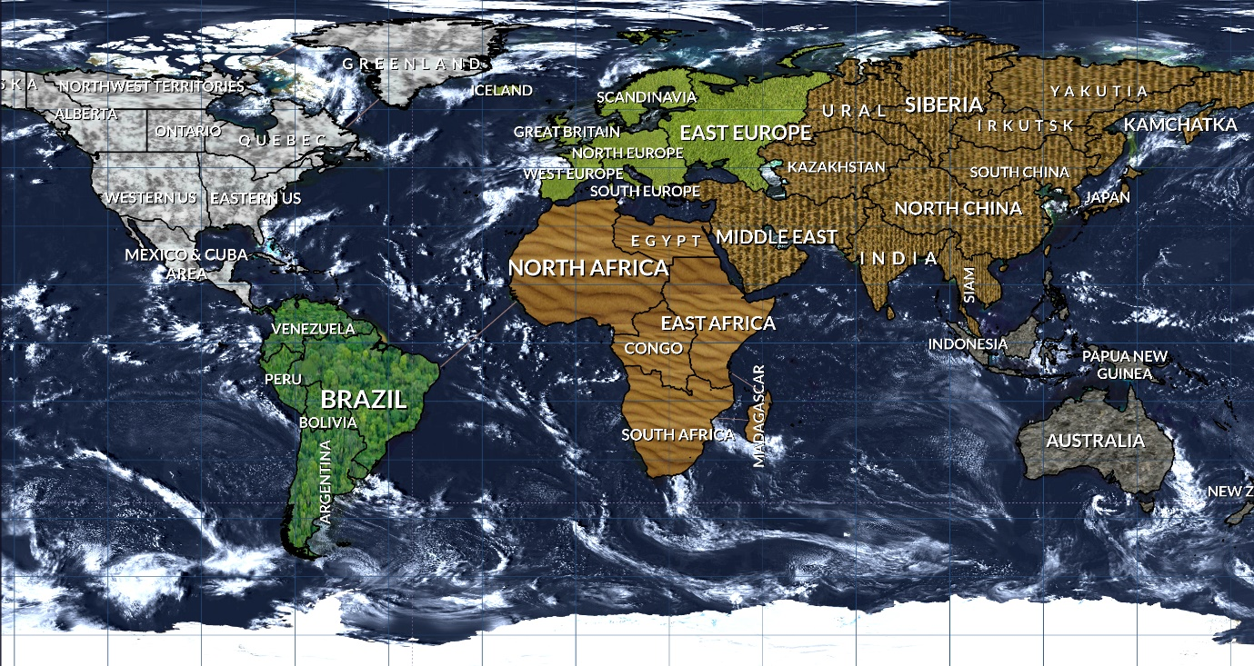

Figure 9 Implementation of the game map

In term of game interface components, all game components in the game, such as the button, panel and menu are developed through the Unity GUI. Unity GUI is the UI system in UnityEngine, which provides a set of tools to arrange the position and style of components in the user interface [20]. Figure 10 below presents a complete game interface. As the section “4.4.1 Functional Components” described, the game components consist of the top panel, recording panel and player panel. In addition, most of the components follow the design in the section except the top panel where there is an additional text-field to display the name of the current player.

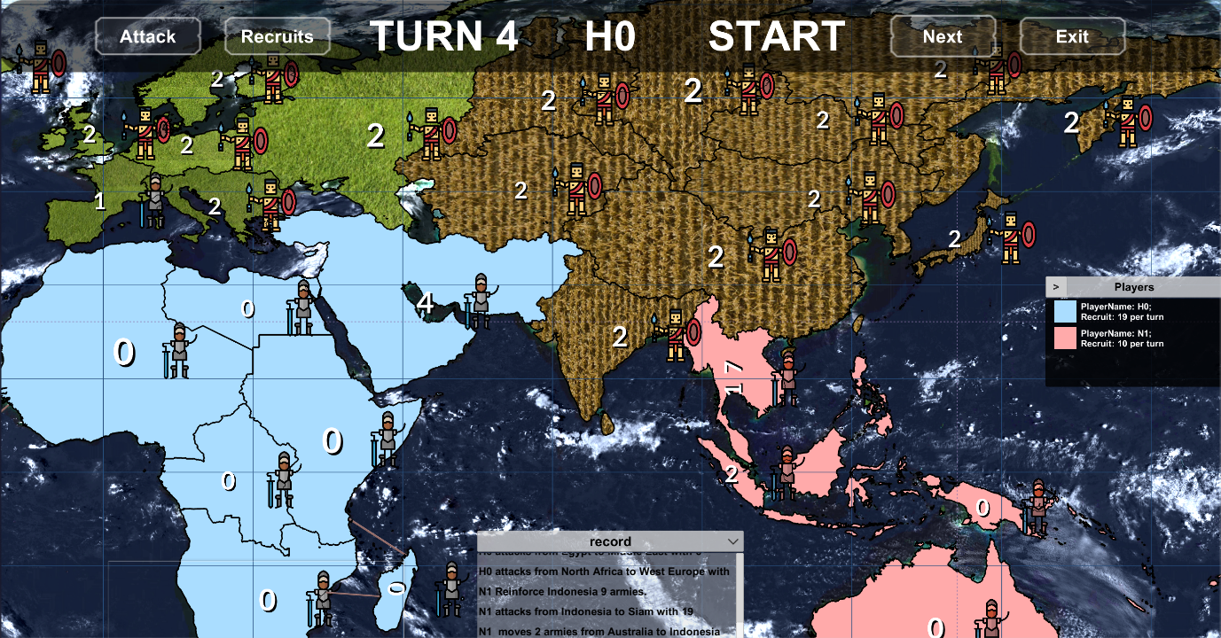

Figure 9 Implementation of the game map

### **5.1.2 Encapsulation to Unity GUI and WFPS**

The encapsulation can reduce the dependence between the program with outside libraries so that, it improves the reusability of the game program. In the project, it is the core for game view implementation to wrap two unity libraries, the WFPS and Unity GUI.

Regarding the encapsulation of the GUI, it provides the controller part the possibility to operate the game components such as the dialogue, the loading panel and the game setting menu. In the project, there are total 8 classes which are used to encapsulate the Unity GUI and there is a predefined interface for these class. Code 01 and Code 02 below show the C# code of the interface and implementation for the loading panel. The boolean variables “isActive” is true when the component is displayed on the screen and “isUpToDate” is true until game over. The two methods “Show” and “Hide” controls whether a game component is displayed on the screen or not.

public interface IRiskViewPanel {  
 bool isActive { get; }  
 bool isUpToDate { get; }

void Show();  
 void Hide();  
}

Code 01: the interface of wrap class

public class RiskLoadingPanel :IRiskViewPanel {  
 public bool isActive => core.activeSelf;  
 public bool isUpToDate => core != null;  
 private readonly GameObject core;  
   
 public RiskLoadingPanel(GameObject panelCore) {  
 core = panelCore;  
 }  
 public void Show() {  
 core.SetActive(true);  
 }  
 public void Hide() {  
 core.SetActive(false);  
 }  
}

Code 02: loading pane class

In term of the Game map view, there are four classes which encapsulate all functions of the library WPFS used in the project. The four classes are the “MapAreaLabeler”, the “MapSurfacePainter”, the “MapTrajectoryMaker” and the “MapEventReceiver”. The previous three classes provide a set of functions to update the map view and the last one monitor human player’s actions, such as moving the pointer into or directly clicking on a specific area, then delivery an event to some matching controller.

Code 03 and Code 04 respectively are the code-sections in WPFS used to colourise surface of the specific area and the encapsulated method in the map colouriser.

var decorator = mapView.decorator.GetAreaDecorator(continent, areaName);

decorator.fillColor = Color.white;

Code 03: The code-sections in WPFS used to colourise the surface of the specific area

private void updateAreaSurfaceColor(string name) {  
 var areaIndex = mapView.GetAreaIndex(name);  
 var area = mapView.countries[areaIndex];  
 var decorator = mapView.decorator.GetAreaDecorator(area.continent, area.name);  
 var priorityStack = areaColorDictionary[name];  
 var highestPriorityColor = priorityStack.GetHighestPriorityElement();

decorator.fillColor = (Color) highestPriorityColor;  
}

Code 04: the encapsulated method in the map colouriser

Code 05 and Code 06 respectively are the code-sections in WPFS used to draw a trajectory from an area to another area and the encapsulated method in the trajectory maker.

var newTrajectory = mapView.AddLine(  
 start: start,  
 end: end,  
 color: color,  
 arcElevation: arc,  
 duration: 0.5f,  
 lineWidth: 0.5f,  
 fadeOutAfter: 0.0f  
);

Code 05: the code-sections in WPFS used to draw a trajectory

public GameObject CreateTrajectory(string fromAreaName, string toAreaName, Color color, float arc) {  
 int startArea = mapView.GetArea(fromAreaName);  
 int endArea = mapView.GetArea(toAreaName);   
 var newTrajectory = mapView.AddLine(  
 start: startArea.centre, end: endArea.centre, color: color,

arcElevation: arc, duration: 0.5f, lineWidth: 0.5f, fadeOutAfter: 0.0f  
 );  
 newTrajectory.SetActive(false);  
 return newTrajectory;  
}

Code 06: the encapsulated method in the trajectory maker

Code 07 and Code 08 respectively are the code-sections in WPFS used to set the label of a specific area and the encapsulated method in the map labeler.

var areaDecorator = mapView.decorator.GetAreaDecorator(continent, areaName);

areaDecorator.customLabel = labelStr;

Code 07: the code-sections in WPFS used to set the label

public void SetLabel(string onAreaName, string labelStr) {  
 var area = mapView.GetArea(onAreaName);  
 var notification = new GameObject();  
 var areaDecorator = mapView.decorator.GetAreaDecorator(area.continent,onAreaName);  
 areaDecorator.customLabel = labelStr;

areaTextLabelDictionary[onAreaName] = labelStr; //Record the value of text label  
}

Code 08: the encapsulated method in the labeler

Code 09 is the original events defined in WFPS, and Code 10 is the encapsulated events. Compared with the original version, these events are more suitable for the controller, because, it encapsulates the process to handle the specific parameters.

public delegate void OnCountryEvent(int countryIndex, int regionIndex);

public event OnCountryEvent OnCountryEnter;  
public event OnCountryEvent OnCountryClick;

Code 09: original events in WFPS

public delegate void mapInteractEventDelegate(string areaName);  
public event mapInteractEventDelegate OnAreaClickEvent;  
public event mapInteractEventDelegate OnAreaEnterEvent;

public MapEvent() {  
 map.OnCountryClick += ClickOnArea;  
 map.OnCountryEnter += MoveOnArea;  
}

private void ClickOnArea(int areaIndex, int regionIndex) {  
 var areaName = WorldMap2D.instance.countries[areaIndex].name;  
 OnAreaClickEvent?.Invoke(areaName);  
}

private void MoveOnArea(int areaIndex, int regionIndex) {  
 var areaName = WorldMap2D.instance.countries[areaIndex].name;  
 OnAreaEnterEvent?.Invoke(areaName);  
}

Code 10: Encapsulated events in the event receiver

### **5.1.4 Changes on View Design**

In the project, there are three different versions of the game view. The first one follows the original interface design in “specification and design document” (see Append 01). The second implementation implements the current interface design described in section 4.4 Interface Design. Compared with these two implementations, the final one extents design in the document to make it more user-friendly.

Figure 10 below is the implementation of the original interface design. In the implementation, there are too many areas on the map to as the game map. In addition, the boundary between two areas, the buttons and the text field on the top of the game view are not clear enough.



Figure 10 Game Interface version 01

And Figure 11 is the second version of the game interface. Compared with the previous design, interface version 2 reduce the areas on the map and re-layout interface components. However, after the demonstration, I realise that it may cause confusion that both continents and players territories are identified through different colours. Therefore, in the final implementation noticed in section 5.1.1, the different textures cover on each continent, instead of colours. In addition, some extension features such as army icon and highlight function are implemented in the final version.

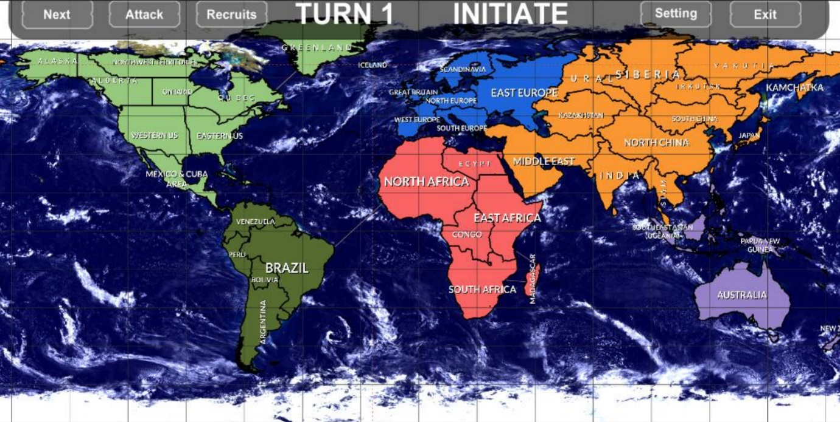

Figure 11 Game Interface version 02

### **5.1.5 Problems Encountered in the game view**

The main problem that occurs during the game view implementation, is how to implement the highlight functionality. The highlight functionality means when a player clicks one area, the area and all its adjacent areas will be highlighted. In addition, the human player can cancel the highlight any time she/he wants. Figure 12 shows the game map when the framing out area is highlighted. It clear to see that the clicked area will be red, and its adjacent areas will be grey when its highlighted.

The problem is how to recover the highlighted areas back to their previous colours or textures after human player cancels it.

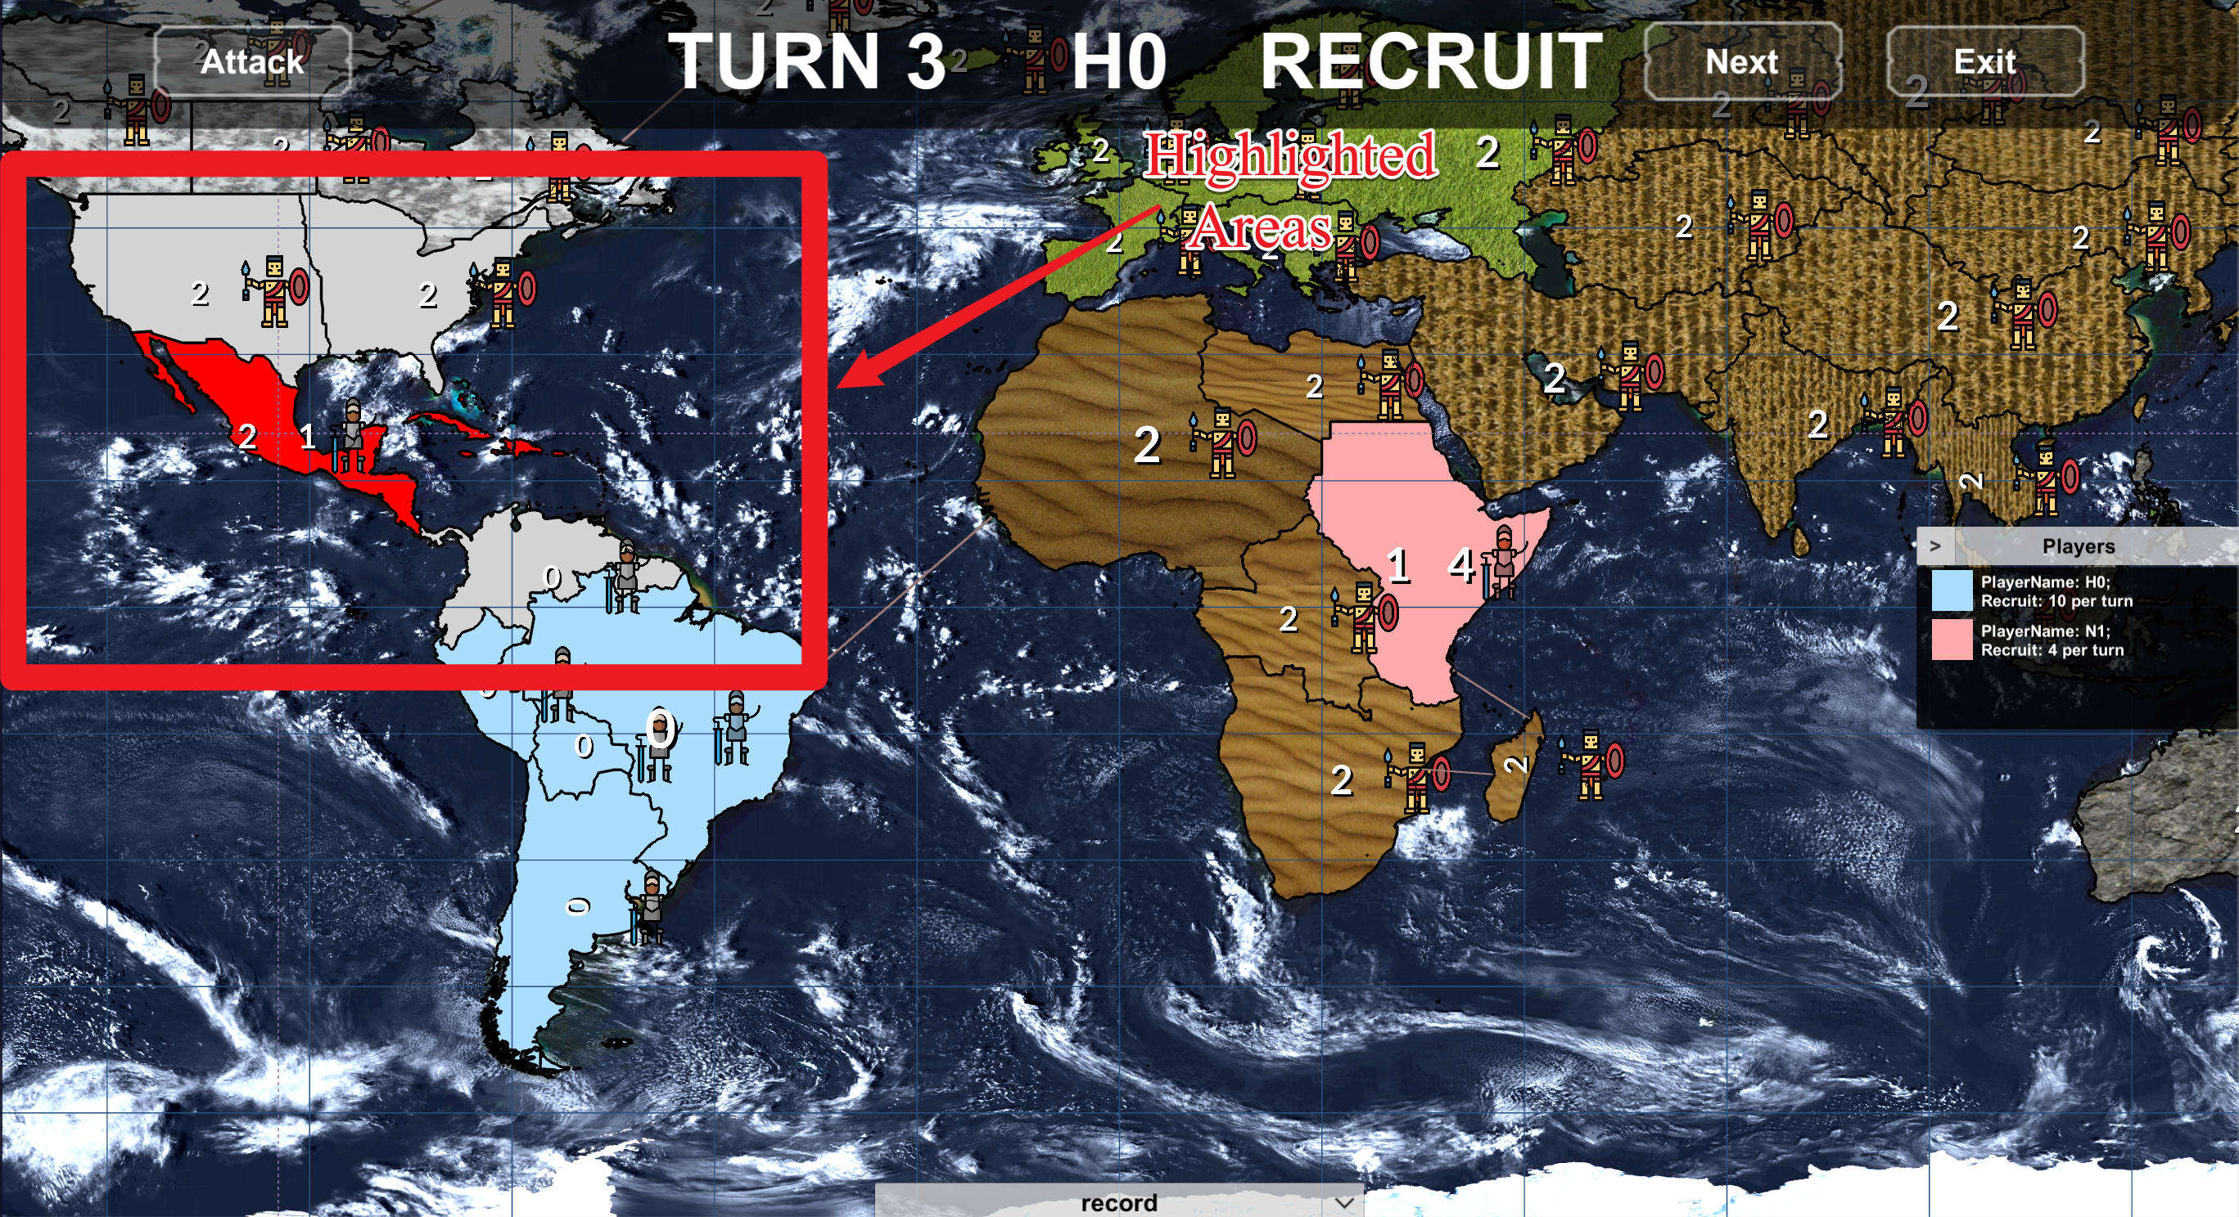

Figure 12 Game Interface version 02

To solve the problem, the data structure priority ordered list, which is described in the section “4.7.2 PriorityOrderedList” is implemented. Code 04 in section 5.1.1 shows how the data structure works in the map surface painter. The colours of each area hierarchically store in an independence instance of this data structure. The map surface painter will only paint the area surface the colour with the highest priority. Code 11 shows a part of the implementation for the priority ordered list.

class PriorityOrderedList<T> {

…  
 private readonly List<(T, int)> stackCore;  
  
 public void Add(T newElement, int atPriority) {  
 if (stackCore.Count == 0 || stackCore.Last().priority < atPriority) {  
 stackCore.Add((newElement, atPriority));  
 return;  
 }

var index= BinarySearch(atPriority);

stackCore.Insert(index, (newElement,atPriority));  
 }  
  
 public (T,int)? GetHighestPriorityElement() {  
 if (stackCore.Count == 0)   
 return null;  
 else

return stackCore.Last();  
 }  
}

Code 11: code sections of Priority Ordered List

In addition, how to access the instance of the game interface components are another problem encountered in this part. These components (such as the dialogue, the menu and configuration panel) are used in many controller classes. Based on the lecture content of COMP319 [21], there are three different methods to share an object between different classes:

* Unity APIs
* Global Static Variables
* Singleton Pattern
* Abstract Factory Pattern

In all four methods, the first one will cause the code duplication. The second one and third one break the conception of object-oriented and the open-closed principle respectively [21]. Therefore, an abstract factory is decided as the solution to the problem. Code 12 is the code section for the implementation of the abstract factory, “战国风云ViewSearcher”. In the class, the method “GetComponentByName” uses C# reflection mechanism and generics to access the components object. It follows the dependency inversion principle so that, the method can access any object of a class which extends the I战国风云Component.

public class **RiskViewSearcher**: MonoBehaviour {

…  
 private GameObject **GameUI**;  
 private Dictionary<Type, IRiskViewPanel> componentCache;  
  
 public T GetComponentByName<T>(string componentName) where T : IRiskViewPanel {  
 if (componentCache.ContainsKey(typeof(T))) {  
 return (T) componentCache[typeof(T)];  
 }  
  
 var componentCore = FindChildObjectByName(fromObject: GameUI, componentName);  
 var parameter = new object[] {componentCore};  
 componentCache[typeof(T)] = (T) Activator.CreateInstance(typeof(T), parameter);  
 return (T) componentCache[typeof(T)];  
 }

private GameObject FindChildObjectByName(GameObject fromObject, string objectName) {  
 var gameObjectNumber = fromObject.transform.childCount;  
 for (var index = 0; index < gameObjectNumber; index++) {  
 var anyChildrenObject = fromObject.transform.GetChild(index).gameObject;  
 if (anyChildrenObject.name == objectName) return anyChildrenObject;  
 }  
 return null;  
 }  
}

Code 12: code section in the 战国风云ViewSearcher

## **5.2 Implementation of Controller**

### **5.2.1 Player Controller**

“Player controller” is a communication channel between the game view and model. The abstract class named “Abstract战国风云PlayerController” is a superclass of all player controller. Code 11 below shows the implementation of the abstract class. There are four protected abstract methods, namely “StartInitiateCore”, “StartRunCore”, “EndTurnCore”, “IsGameOver” and “IsInitiated”. All abstract methods are used in a public method “StartRun” which will be invoked when a player’s game turn starts. In addition, there is an abstract event named “EndTurnEvent” which is generated when the player ends own game turn. All player class just need to implement these abstract methods and event.

public abstract class AbstractPlayerController {  
 public delegate void PlayerEventDelegate();  
 public abstract event PlayerEventDelegate EndTurnEvent;  
  
 public void StartRun() {  
 if (!IsInitiated()) // if the game player does not finish initiation  
 StartInitiateCore();

else if (IsGameOver()) // if the game is over  
 EndTurnCore();  
 else   
 StartRunCore();  
 }  
 protected abstract bool IsInitiated()  
 protected abstract bool IsGameOver();  
 protected abstract void StartRunCore();  
 protected abstract void StartInitiateCore();  
 protected abstract void EndTurnCore();  
}

Code 13: code section of Abstract Player Controller

For a human player, the player controller interprets her/his behaviour and then, invokes different functions in the game model to handle it after that, the player controller deliveries the result to game view. In the project, there is one human player controller, “战国风云HumanPlayerController”. Code 14 is the code section for the human player controller.

protected override IEnumerator StartInitiateCore() {  
 controllerDictionary[GamePhase.INITIATE] = new InitiateMapInteractionController();;  
 controllerDictionary[GamePhase.START] = new TurnStartPhaseController();  
 controllerDictionary[GamePhase.RECRUIT] = new RecruitMapInteractionController();  
 controllerDictionary[GamePhase.ATTACK] = new AttackMapInteractionController();  
 controllerDictionary[GamePhase.END] = new TurnEndPhaseController();  
 SetCurrentController(GamePhase.INITIATE);  
}

protected override IEnumerator StartRunCore() {  
 gameCanvas.Show();  
 gameCanvas.PlayerText = playerName;  
 gameCanvas.OnClickNextTurnButton += EndTurn;  
 gameCanvas.OnClickRecruitTurnButton += StartRecruitPhase;  
 gameCanvas.OnClickAttackButton += StartAttackPhase;  
 SetCurrentController(GamePhase.START);  
}

private void EndInitiate() {  
 SetCurrentController(GamePhase.END);  
 EndTurnEvent?.Invoke();  
}

private void SetCurrentController(GamePhase atPhase) {  
 currentMapController?.Stop();  
 currentMapController = controllerDictionary[atPhase];  
 currentMapController.Work();  
 gameCanvas.PhaseText = atPhase.ToString();  
}

Code 14: code core of Human Player Controller

For the computer player, the player controller directly sends the message to AI core to produce a strategy based on current conditions after that, the controller also sends results to the game view. In the project, there are 3 computer player controllers namely, “战国风云AggressiveComputerPlayer”, “战国风云ConservationComputerPlayer” and “战国风云RandomComputerPlayer”. Code 15 is the code section for aggressive computer player controller.

private AggressiveComputerCore aiCore;

protected override void StartInitiateCore() {  
 aiCore.Observation();  
 var initiateStrategy = aiCore.DeployPhaseReasoning();

execute(initiateStrategy);

EndTurnEvent?.Invoke();  
}

protected override void StartRunCore() {  
 aiCore.Observation();//Recruit Phase  
 var recruitStrategy = aiCore.DeployPhaseReasoning();

execute(recruitStrategy);   
 aiCore.Observation();//Attack Phase

var attackStrategy = aiCore.AttackPhaseReasoning();

execute(attackStrategy);   
 aiCore.Observation();//Schedule Phase

var scheduleStrategy = aiCore.SchedulePhaseReasoning();

execute(scheduleStrategy);

EndTurnEvent?.Invoke();  
}

protected override void EndTurnCore() {  
 EndTurnEvent?.Invoke();  
}

private void Execute(RiskStrategy strategy){

var actionEnumerator = strategy.GetEnumerator();

while(actionEnumerator.MoveNext()) {  
 var action = actionEnumerator.Current;  
 var command = Command.buildFrom(action);  
 commandInvoker.ExecuteCommand(playerName, command);  
 }

}

Code 15: code section in computer Player Controller

### **5.2.2 Player Controller Manager**

“PlayerControlleManager” schedules all player’ game turn. When any player’s game turn finish, the player controller manager will notify next player’s controller to start next game turn. Code 16 below shows the code-section of the “战国风云ControllerManager”. The class directly communicates with an abstract player controller instead of a specific player controller class. It follows the dependency inversion principle.

public class **RiskControllerManager**: MonoBehaviour {

…

private int totalRunTimes;

private List<AbstractPlayerController> playerControllers;

private int currentTurn => totalRunTimes / playerControllers.Count;

private int currentPlayerIndex => totalRunTimes % playerControllers.Count;  
  
 private void MoveToNextPlayer() {  
 totalRunTimes += 1;  
 playerCanvas.TurnNumber = currentTurn;  
 playerIdentifyPanel.UpdateAllPlayers();  
 playerControllers[currentPlayerIndex].StartRun()  
 }

}

Code 16: code section of Player Controller Manager

### **5.2.3 Command and Invoker**

Command and Invoker are the implementations of the command pattern. In the project, Command provides both human and computer player controller a set of methods to update the game view and Invoker will execute these commands generated from the player controller. Code 14 and Code 15 below are the interface for all commands and implementation of Invoker.

interface IRiskCommand {  
 bool Execute();  
 bool Rollback();  
}

Code 17: code of ICommand

public class RiskCommandInvoker {

…

private readonly Dictionary<Type, AbstractRiskUniqueCommand> exclusiveCommandDictionary;

public bool ExecuteMultipleCommand (string playerName, AbstractRiskMultipleCommand command) {  
 if (command.Execute()) {  
 return true;  
 } else {  
 riskMultipleCommand.Rollback();  
 return false;  
 }  
 }

public bool AbortLastMultipleCommand() {  
 var transaction = multipleCommandDeque.Last();  
 multipleCommandDeque.RemoveLast();  
 return transaction.Rollback();  
 }

public bool ExecuteExclusiveCommand(AbstractRiskExclusiveCommand command) {  
 var type = command.GetType();  
 if(exclusiveCommandDictionary.ContainsKey(type))  
 exclusiveCommandDictionary[type].Rollback();  
 exclusiveCommandDictionary[type] = command;  
 return command.Execute();  
 }

public bool RollbackExclusiveCommand<T>() {  
 var type = typeof(T);  
 return exclusiveCommandDictionary.ContainsKey(type)  
 && exclusiveCommandDictionary[type].Rollback()  
 && exclusiveCommandDictionary.Remove(type);  
 }

}

Code 18: code section of Player Controller Manager

### **5.2.4 Changes on Controller Design**

The implementation of the controller part is completely different from the previous design and strictly follows the current design in section 4.5 Component Design. Figure 13 below is the controller part of the previous class diagram. Compared with the real program, the original design is simpler because it invokes the APIs provided by Unity library and implements a class “NotificationCentre” which send message directly to these unity scripts to update the game view. The previous design, however, causes a high-coupling program. In addition, it ignores how to implements the game turn and to handle different players’ actions.

In contrast, the current one reaches the requirement, high-coherence and low-coupling. Generally, in the game program, various player controllers handle different players actions; the player controller manager schedules the game turn and the command with its invoker update the game view.

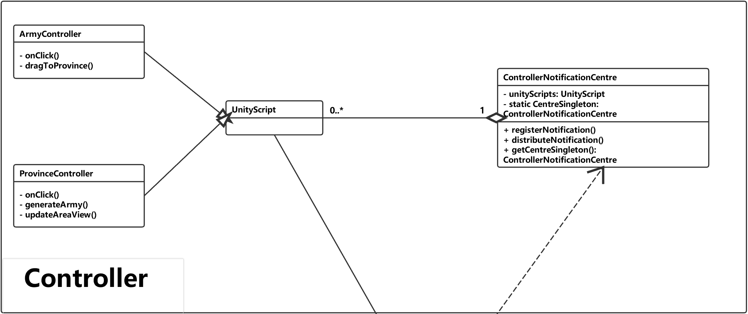

Figure 13 the controller part in the previous class diagram

### **5.2.5 Problems Encountered on the game controller**

In the human player controller, the game view needs a mechanism to response player same actions in different conditions, for example, if a player clicks own territory, it will be highlighted in the reinforcing phase but will not be highlighted in the initiating phase. So, the first problem is how to respond to the player’s same actions in different condition. There are two different ways to solve the problem.

* The first way is to implement a set of methods in a class, HumanPlayerController, to handle all possible actions of a human player. It may be able to solve the problem but, the class will break the single responsibility principle [21]. Because, it means the class needs to handle human players behaviours in at least three different game phases (such as, Initiating phase, Deploying phase, Attacking phase) and there are more than three different actions in each phase (such as, clicking certain area, moving the mouse pointer and pressing some button).
* The second one is to implements a set of classes to handle the player’s actions independently in different phases. It is used in the project and Code 15 in section 5.2.1 describes how it works. When a player changes from a phase to another one, “HumanPlayerController” will change the value of the variable named phaseCore and will handle human player’s action through the variable, instead of the different methods. There is an abstract class named “AbstractHumanPlayerPhaseControllerCore” which specifies the variables and functions in a phase controller core class. Code 19 below shows the code section of the class.

public abstract class AbstractHumanPlayerPhaseControllerCore {  
 public void Work() {  
 MapEvent.instance.OnAreaClickEvent += HandleOnAreaClick;  
 MapEvent.instance.OnAreaEnterEvent += HandleOnAreaEnter;  
 MapEvent.instance.OnEscPressEvent += HandleOnEscPress;  
 WorkCore();  
 }  
 public void Stop() {  
 MapEvent.instance.OnAreaClickEvent -= HandleOnAreaClick;  
 MapEvent.instance.OnAreaEnterEvent -= HandleOnAreaEnter;  
 MapEvent.instance.OnEscPressEvent -= HandleOnEscPress;  
 StopCore();  
 }  
  
 protected virtual void WorkCore() {}  
 protected virtual void StopCore() {}  
   
 protected abstract void HandleOnAreaClick(string clickedCountryName);  
 protected abstract void HandleOnAreaEnter(string countryName);  
 protected abstract void HandleOnEscPress();

}

Code 19: code section of Player Controller Manager

The abstract class encapsulates the event binding and provides two public methods namely “Work” and “Stop”. In the two method, it will bind events (OnAreaClickEvent, OnAreaEnterEvent and OnEscPressEvent) from game map with abstract methods (“HandleOnAreaClick”, “HandleOnAreaEnter” and “HandleOnEscPress”). Code 20 below shows code-section of class “InitiatePhaseControllerCore”.

public class InitiatePhaseControllerCore: AbstractHumanPlayerPhaseControllerCore {

private readonly RiskViewDialog notificationDialog;  
  
 protected override void WorkCore() {/*Do nothing*/}  
  
 protected override void StopCore() {/*Do nothing*/}

protected override void HandleOnAreaEnter(string countryName) {/*Do nothing*/}  
  
 protected override void HandleOnEscPress() {/*Do nothing*/}

/*In this phase, we do not need the class to do anything else*/  
 protected override void HandleOnAreaClick(string clickedCountryName) {  
 if (dataManager.GetOwnerName(clickedCountryName) != null) return;  
 selectedCountryName = clickedCountryName;  
 commandInvoker.ExecuteMultipleCommand(  
 playerName, new SelectFirstCommand(playerName, selectedCountryName)  
 );  
 }  
}

Code 20: code section of Initiate Phase Controller Core

The second problem is how to update the game view at some special situation such as updating the attack preview line. Figure 14 below shows a framing out attack preview line. Because, there can be only one attack preview line displayed on the map, the previous line needs to be removed before drawing the new one.

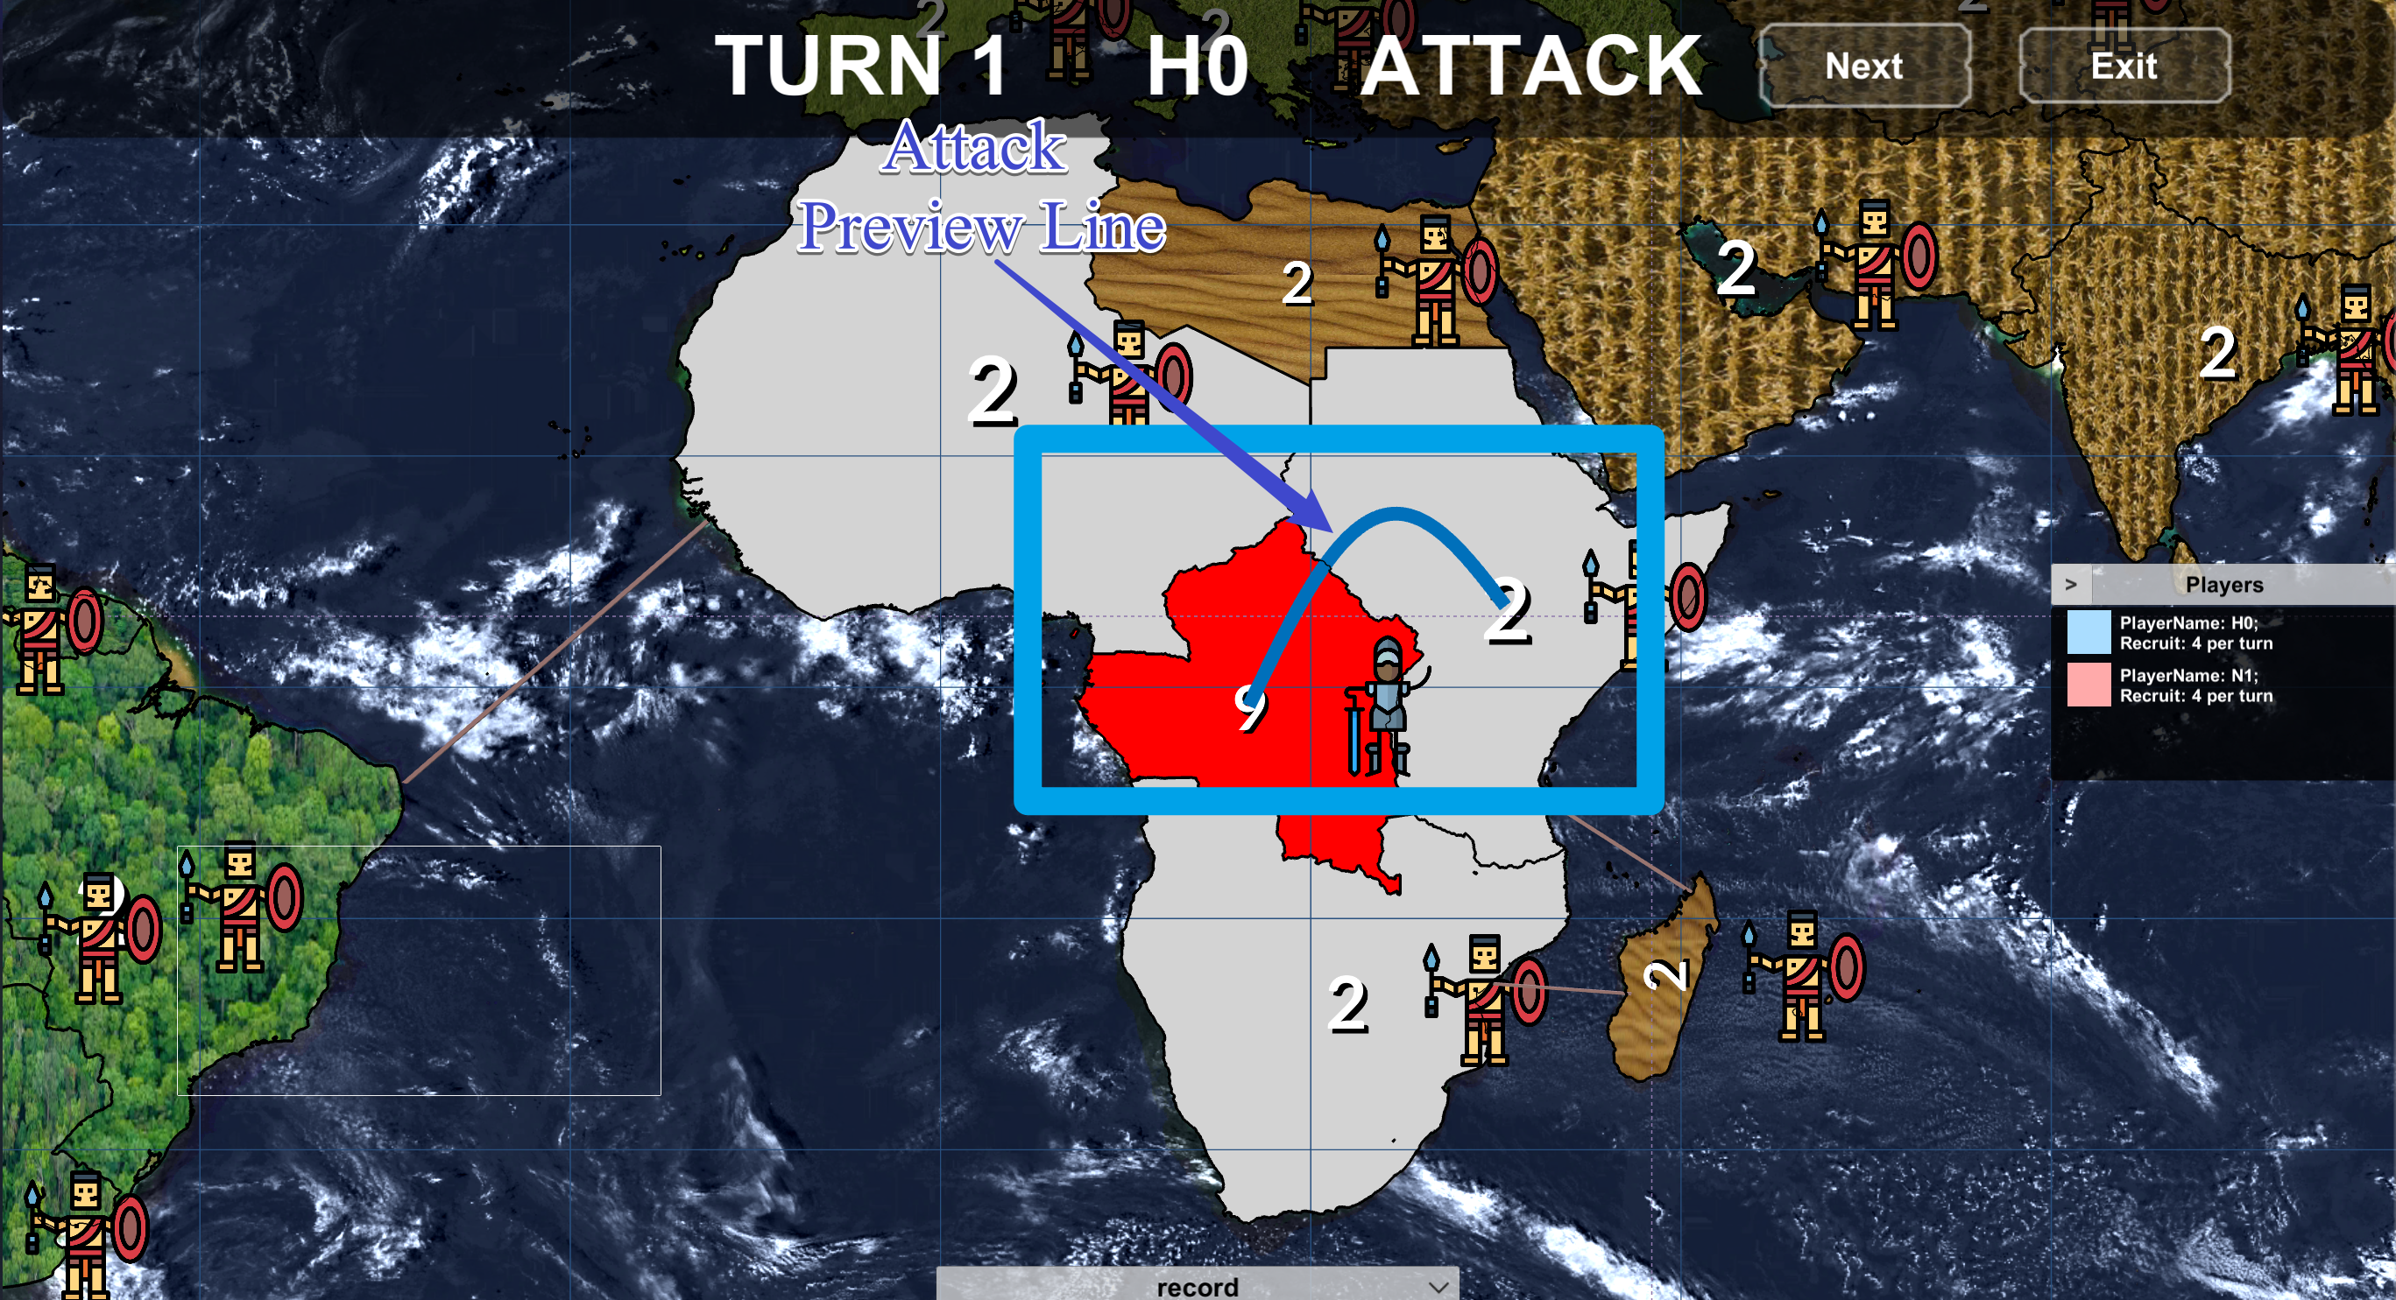

Figure 14: Attack preview line

In the project, the exclusive command is used to solve the problem. Code 18 in section 5.2.8 shows how the exclusive command work. It will rollback the previous command from the same class and then, execute the new command.

## **5.3 Implementation of Model**

### **5.3.1 Data and Data Model**

Code 21 below is complete code for “AbstraceData”, which an abstract class for the data is used in the game model. There is a total of three class implements the abstract class, namely “PlayerData”, “AreaData” and “ContinentData”. In addition, game data class can be directly converted from the JSONNode object.

public class AbstractData {  
 public readonly int ID;  
   
 public AbstractData(JSONNode rawData) {  
 ID = rawData["ID"].AsInt;  
 }  
}

Code 21: code section of Initiate Phase Controller Core

Code 22 below shows the code section of the “战国风云DataModel”. It is a container class which manages all these data with their relations and it also provides a set of functions to operate these data. It clear to see that all data are directly stored in the three different lists and the relation between there are stored in the RelationMatrix. In addition, the class is encapsulated in both “战国风云LogicCore” and “战国风云DataManager” to provide the controller essential data.

public class RiskGameDataModel {  
 //1. Geography Data  
 //1.1 Data Model for the areas;  
 private readonly List<AreaData> areasList;  
 private readonly RelationMatrix areasAdjacencyMatrix;  
  
 //1.2 Data Model for the continents;  
 private readonly List<ContinentData> continentsList;  
 private readonly RelationMatrix continentAreasMatrix;  
   
 //2. Player Data  
 private readonly List<PlayerData> playersList;  
 private readonly RelationMatrix playerTerritoriesMatrix;  
  
 private RiskGameDataModel() {  
 //1. Initiate Area Data Model;  
 var AreaDataFile= JsonFile.GetJsonFile(FilePath.AreasDataAbsPath);  
 var areaDataConverter =

new RiskDataConverter<AreaData>(AreaDataFile.Read().AsArray);  
 areasList = areaDataConverter.GetTargetDataList();  
 var areaNum = areasList.Count;  
 areasAdjacencyMatrix = areaDataConverter.GetRelationMatrix(  
 with: "Neighbours", row:areaNum, column:areaNum  
 );  
 //2. Initiate the Continent Data Model  
 var continentDataFile = JsonFile.GetJsonFile(FilePath.ContinentsDataAbsPath);  
 var continentDataConverter =

new RiskDataConverter<ContinentData>(continentDataFile.Read().AsArray);  
 continentsList = continentDataConverter.GetTargetDataList();  
 var continentNum = continentsList.Count;  
 continentAreasMatrix = continentDataConverter.GetRelationMatrix(  
 with: "Countries", row:continentNum, column:areaNum  
 );  
 //3. Initiate the Player Data model  
 var playerDataFile = JsonFile.GetJsonFile(FilePath.PlayersDataAbsPath);  
 var playerDataConverter =

new RiskDataConverter<PlayerData>(playerDataFile.Read().AsArray);  
 playersList = playerDataConverter.GetTargetDataList();  
 var playerNum = playersList.Count;  
 playerTerritoriesMatrix = playerDataConverter.GetRelationMatrix(  
 with: "Countries", row:playerNum, column:areaNum  
 );  
 }

…  
}

Code 22: code section of Initiate Phase Controller Core

### **5.3.2 Input and Output**

Code 23 below is the code section for the “JsonFile”, which is an encapsulation of the SimpleJSON package. In addition, it provides a function to read and write local json files.

public class JsonFile {  
 private readonly AbsolutePath path;  
 private JSONNode jsonNode;

private JsonFile(AbsolutePath path) {  
 this.path = path;  
 var pathStr = File.Exists(path.Runtime) ? path.Runtime : path.Default;  
 string jsonStr;  
 if (Application.platform == RuntimePlatform.Android) { // if it is android platform  
 var reader = new WWW(pathStr);  
 while (!reader.isDone) { }  
 jsonStr = reader.text;  
 }  
 else{  
 jsonStr = File.ReadAllText(pathStr);  
 }   
 jsonNode = JSON.Parse(jsonStr);  
   
 }  
   
 public JSONNode Read() {  
 return jsonNode;  
 }  
  
 public void Write(JSONNode data) {  
 jsonNode = data;  
 }

}

Code 23: code section of Json File

### **5.3.3 Artificial Intelligent**

Figure 15 below shows the “Ontology” model in artificial intelligent. It is clear to see that the AI “Ontology” consists of three different parts: the first one is the “Enemy Territory” in the periphery of the graph, the second one is “FrontLine” which directly connects with the “Enemy Territory” and remaining nodes is “HomeLine”. The implementation of the class “战国风云ComputerOntology” completely follows the design of data structure BalanceGraph introduced in the section 4.7.4 BlanaceGraph.

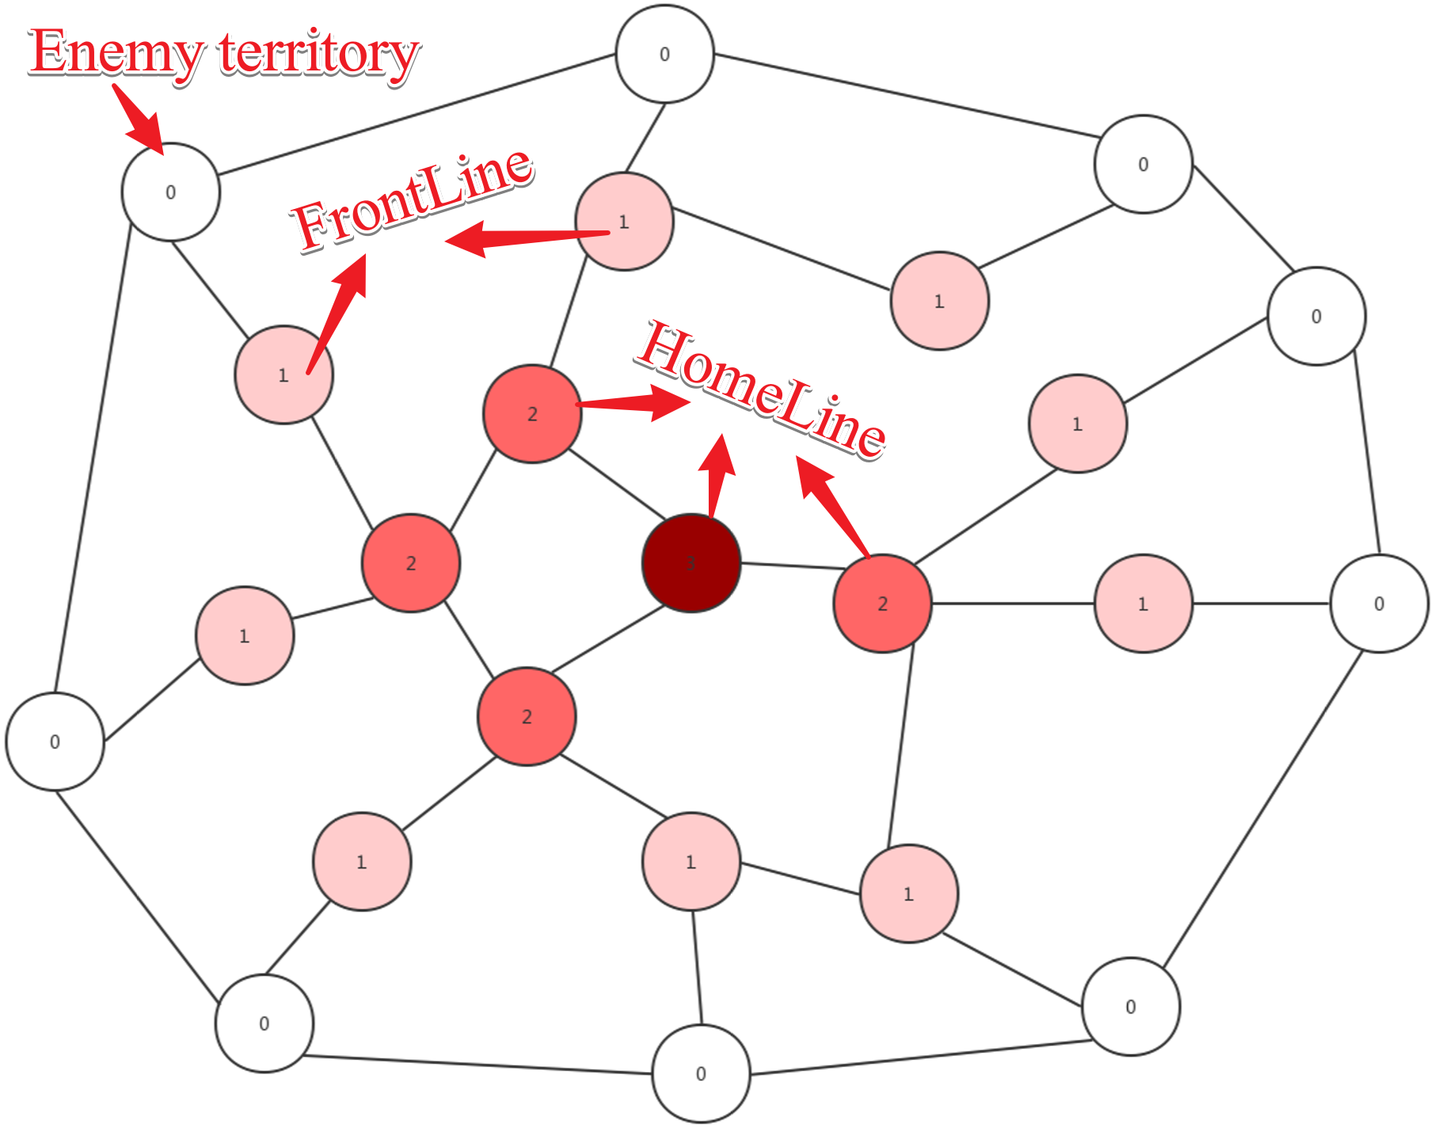

Figure 15: Ontology

Code 24 below is the code section for “Ontology”, which the class provides the AI core with essential data to produce a strategy. Generally, the class implements for the data structure “BalanceGraph”. variables frontline and home-line provides a method to access the nodes data with specific levels. The two methods “BuildGraph” and “UpdateBalances” provide methods to update data stored in Ontology and estimate the size of armies required in each territory to fortify.

public class RiskComputerOntology {  
 private readonly Dictionary<AreaData, BalanceNode> ontologyCore;  
  
 public List<BalanceNode> FrontLine => (  
 from node in ontologyCore.Values  
 where node.isFrontLine()  
 orderby node.ArmiesBalance descending  
 select node  
 ).ToList();  
   
 public List<BalanceNode> HomeFront => (  
 from node in ontologyCore.Values  
 where ! node.isFrontLine()  
 orderby node.ArmiesBalance descending  
 select node  
 ).ToList();  
   
 public void BuildGraph(){  
 var playerTerritoriesList = GetAreasListInTerritory(playerName);  
 //Add new neighbours  
 playerTerritoriesList.ForEach(playerTerritoryData => {  
 if(ontologyCore.ContainsKey(playerTerritoryData)) return;  
 var nearbyAreaDataList = GetNeighboursList(playerTerritoryData.Name);  
 var nearbyTerritoriesNodes = (  
 from nearbyAreaData in nearbyAreaDataList  
 where ontologyCore.ContainsKey(nearbyAreaData)  
 select ontologyCore[nearbyAreaData]  
 ).ToList();  
 var newNode = new BalanceNode(playerTerritoryData);  
 newNode.ConnectWithNearbyTerritories(nearbyTerritoriesNodes);  
 ontologyCore[playerTerritoryData] = newNode;  
 });  
 //Delete the neighbours which is invalid  
 var removedNodesList = new List<AreaData>();  
 foreach (var ontologyPair in ontologyCore) {  
 var ontologyAreaData = ontologyPair.Key;  
 if(playerTerritoriesList.Contains(ontologyAreaData)) continue;  
 ontologyCore[ontologyAreaData].DisconnectWithNearbyTerritories();  
 removedNodesList.Add(ontologyAreaData);  
 }  
 removedNodesList.ForEach(data=>ontologyCore.Remove(data));  
   
 HomeFront.ForEach(homeFrontNode => homeFrontNode.PrepareForLevelBoardCast());  
 FrontLine.ForEach(frontLineNode => frontLineNode.LevelBoardCast());  
 }  
   
  
 public void UpdateBalance() {  
 var level = 0;  
 List<BalanceNode> nodesInSameLevel;  
 do {  
 nodesInSameLevel = (  
 from node in ontologyCore  
 where node.Value.CurrentLevel == level  
 select node.Value  
 ).ToList();  
 nodesInSameLevel.ForEach(node => {  
 node.PrepareForBalanceBoardCast();  
 node.BalanceBoardCast();  
 });  
 level += 1;  
 } while (nodesInSameLevel.Any());  
 }

}

Code 24: code section 战国风云 Computer Ontology

Code 25 below is the code section for the method DeployPhaseReasoning in the class “AggressiveComputerPlayerCore”. In this part, the AI player follows the rules below:

* If the size of recruit is smaller than the sum of negative balance for all frontline nodes, deploys recruits into each of these nodes as many as possible and the size of recruits equals to its balance value.
* If the size of the recruit is bigger, the AI core will increase the army’s size of these nodes to make their balance be zero and the randomly deploys remaining recruits.

public RiskStrategy<ReinforcementAction> DeployPhaseReasoning() {  
 var strategy = new RiskStrategy<ReinforcementAction>();  
 var recruitNumber = RiskLogicCore.instance.GetPlayerRecruitSize(player.Name);  
 var frontLineList = ontology.FrontLine;  
 frontLineList.ForEach(node => {  
 if (recruitNumber <= 0) return;  
 if (node.ArmiesBalance >= 0) return;  
 var armiesShortage = -node.ArmiesBalance;  
 var newAction = new ReinforcementAction(  
 areaName:node.areaData.Name, size:Math.Min(armiesShortage, recruitNumber)  
 );  
 strategy.Add(newAction);  
 recruitNumber -= armiesShortage;  
 });  
 if (recruitNumber <= 0) return strategy;  
 var tmpIndex = 0;  
 while (recruitNumber > 0) {  
 var tmpNode = frontLineList[tmpIndex % frontLineList.Count];  
 var newStrategy = new ReinforcementAction(  
 areaName: tmpNode.areaData.Name, size: 1  
 );  
 strategy.Add(newStrategy);  
 recruitNumber -= 1;  
 tmpIndex += 1;  
 }  
 return strategy;  
}

Code 25: code section for DeployPhaseReasoning in “AggressiveComputerPlayerCore”

Code 26 below is the code section for the method AttackPhaseReasoning in the class “AggressiveComputerPlayerCore”.

public RiskStrategy<MoveAction> AttackPhaseReasoning() {  
 var strategy = new RiskStrategy<MoveAction>();  
 var frontLineList = ontology.FrontLine;  
 frontLineList.ForEach(frontLineNode => {  
 var actionList = frontLineNode.ArmiesBalance >= 0  
 ? AttackWithAbsoluteNumericalSuperiority(frontLineNode)  
 : AttackWithRelativeNumericalSuperiority(frontLineNode);  
 actionList.ForEach(action => strategy.Add(action));  
 });  
 return strategy;  
}

Code 26: code section for method “AttackPhaseReasoning” in “AggressiveComputerPlayerCore”

According to the code section, it is clear to see that the aggressive computer player core will make an attacking plan for armies in frontline and the plan follows different logic in different situations.

* If the value of the army balance in a frontline node is larger than zero, the player has absolute numerical superiority in the current area, comparing with other players who occupy adjacent areas. Therefore, the player core will attack these adjacent areas which are under enemies’ control.
* Else, if the value of the army balance in the area is negative, but the local army size is larger than the maximal enemy armies in the adjacent areas, the player has relative numerical superiority in the area. Therefore, the player core will attack these adjacent enemy-territories until it loses the superiority.
* Else, the player core will not launch an attack from this territory.

Methods “AttackWithAbsoluteAdvance” and “AttackWithRelativeAdvance” implement these logics noticed. Code 27 is the code for the method “AttackWithAbsoluteAdvance”.

private List<MoveAction> AttackWithAbsoluteNumericalSuperiority(BalanceNode frontLineNode){  
 /*attack adjacent areas which are under enemies’ control*/  
 var actionList = new List<MoveAction>();  
 var frontLineAreaData = frontLineNode.areaData;  
 var nearbyAreasList = dataModel.GetNeighboursList(frontLineAreaData.Name);  
 var nearbyEnemyAreasList = nearbyAreasList.FindAll(data =>  
 dataModel.GetOwner(data.Name) != player  
 );  
 var availableAttackerSize = frontLineAreaData.ActiveArmiesSize;  
 nearbyEnemyAreasList.ForEach(neighbourData => {  
 var attackerSize = neighbourData.TotalArmiesSize;  
 var newAction = new MoveAction(frontLineAreaData.Name,neighbourData.Name,attackerSize);   
 actionList.Add(newAction);  
 availableAttackerSize -= attackerSize;  
 });  
 /*Averagely increase the size of attacker*/  
 var tmpIndex = 0;  
 while (availableAttackerSize > 0) {  
 tmpIndex = tmpIndex % nearbyEnemyAreasList.Count;  
 var enemyAreaData = nearbyEnemyAreasList[tmpIndex];  
 var newStrategy = new MoveAction(frontLineAreaData.Name, enemyAreaData.Name, 1);  
 actionList.Add(newStrategy);  
 availableAttackerSize -= 1;  
 tmpIndex += 1;  
 }  
 return actionList;  
}

Code 27: code section for method “AttackPhaseReasoning” in “AggressiveComputerPlayerCore”

Code 28 below is the code section for method “SchedulePhaseReasoning” in the class “AggressiveComputerPlayeCore”. In the method, it makes each home-line node delivery its own armies to higher level nodes which need to fortify.

public RiskStrategy<MoveAction> SchedulePhaseReasoning() {  
 var strategy = new RiskStrategy<MoveAction>();  
 ontology.HomeFront.ForEach(homeFrontNode => {  
 var homeFrontAreaData = homeFrontNode.areaData;  
 var activeArmiesSize = homeFrontAreaData.ActiveArmiesSize;  
 if (activeArmiesSize == 0) return;  
 var nodeNeighbours = homeFrontNode.NeighbourTerritoriesNodes;  
 var neighboursHighLevelNodesList = nodeNeighbours.FindAll(neighbourNode =>  
 neighbourNode.CurrentLevel < homeFrontNode.CurrentLevel  
 );  
 neighboursHighLevelNodesList.ForEach(neighbourNode => {  
 if (activeArmiesSize <= 0) return;  
 if (neighbourNode.ArmiesBalance >= 0) return;  
 var armiesShortage = -neighbourNode.ArmiesBalance;  
 var newAction = new MoveAction(  
 fromName: homeFrontAreaData.Name,  
 toName: neighbourNode.areaData.Name,   
 size: Math.Min(activeArmiesSize, armiesShortage)  
 );  
 strategy.Add(newAction);  
 activeArmiesSize -= armiesShortage;  
 });  
 var tmpIndex = 0;  
 while (activeArmiesSize > 0) {  
 tmpIndex = tmpIndex % neighboursHighLevelNodesList.Count;  
 var highLevelNodes = neighboursHighLevelNodesList[tmpIndex];  
 var newStrategy =

new MoveAction(homeFrontAreaData.Name, highLevelNodes.areaData.Name,1);   
 strategy.Add(newStrategy);  
 activeArmiesSize -= 1;  
 tmpIndex += 1;  
 }  
 });  
 return strategy;  
}

Code 28: code section for method “AttackPhaseReasoning” in “AggressiveComputerPlayerCore”

### **5.3.4 Changes in Model Design**

Similar to the controller part, the implementation of the game model is completely different from the previous game model design and strictly follows the current one in section 4.5.3.

Figure 16 below is the class diagram in “Specification and Design Document”. Compared with the current one, the class named “战国风云Game” breaks the single responsibility principle because the class needs to handle the data querying and the logic method invoking from the player controller model. In addition, the design did not consider how AI execute in the game program.

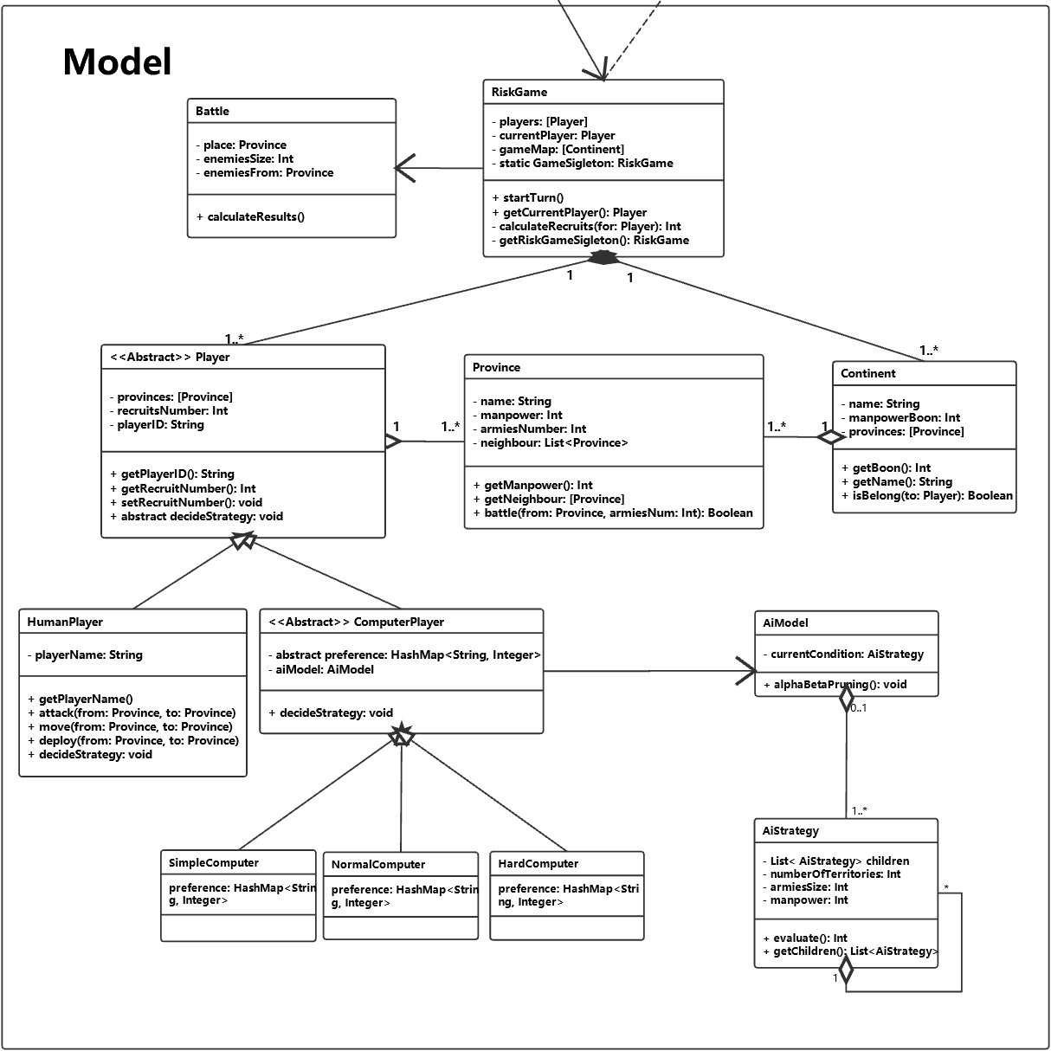

Figure 16 Previous Game Model Design

### **5.3.5 Problems Encountered on the game model**

The first problem encountered in this part is how to store and manage neighbour relations between different areas. Figure 17 describes the basic information about areas and their relations.

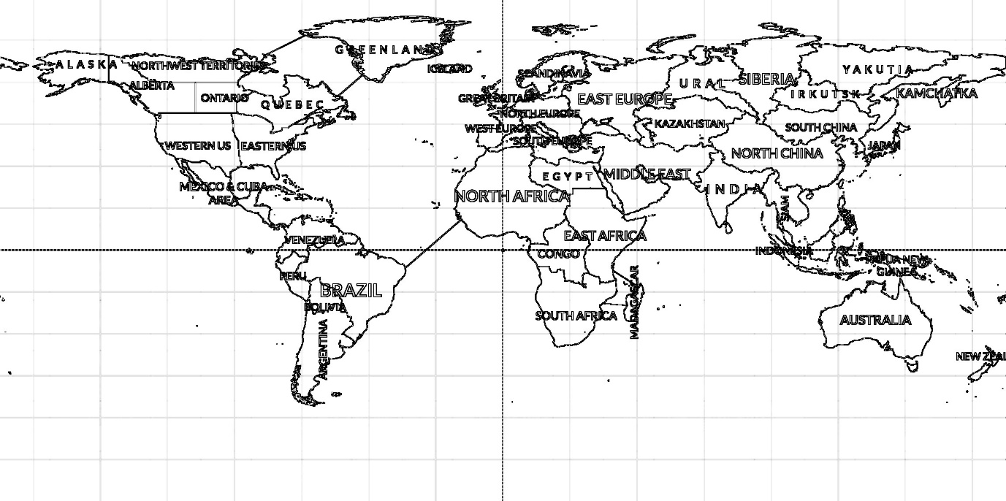

Figure 17 basic relation between each area

Based on the lecture content of CSE102 [22], the geography information on the map can be stored into an undirected graph in which a node presents an area and an edge between two nodes means that the two nodes are adjacent. Figure 18 shows the undirected graph.

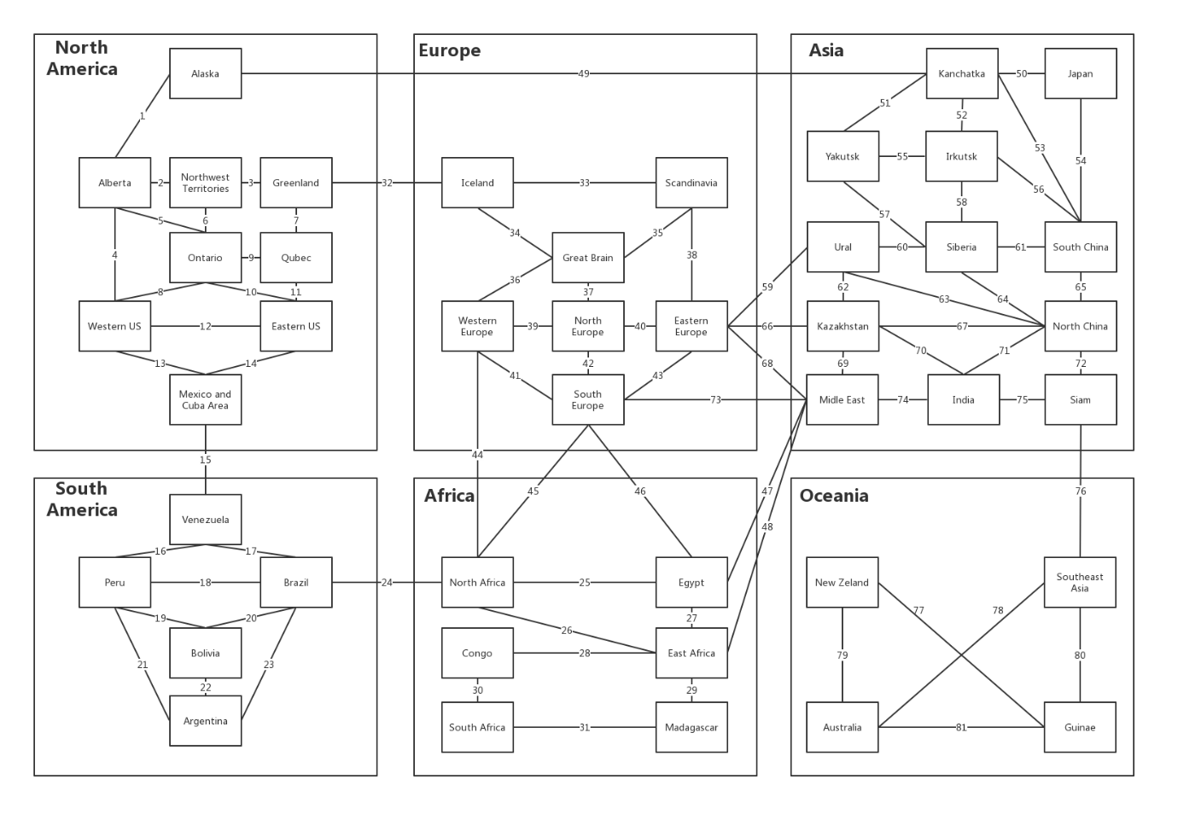

Figure 18 Undirected Graph of the game map

Therefore, the problem now is how to store an undirect graph in the program. It is notified that the adjacent matrix is a solution to the problem. Figure 19 is part of the adjacent matrix.

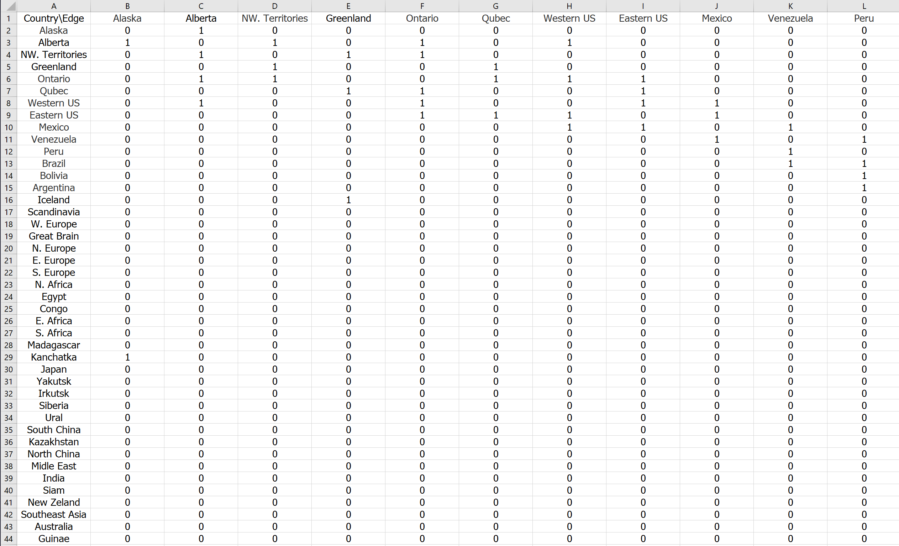

Figure19 Part of the adjacent matrix

In the project, a class named “RelationMatrix” implements the adjacent matrix in the graph. Code 29 is the complete code of the adjacent matrix.

public class RelationMatrix {  
 private readonly byte[][] matrixCore;  
  
 public RelationMatrix(int row, int column) {  
 matrixCore = new byte[row][];  
 for (var rowIndex = 0; rowIndex < matrixCore.Length; rowIndex++)   
 matrixCore[rowIndex] = new byte[column];  
 }  
  
 public void SetRelation(int row, int column, bool isExist) {  
 matrixCore[row][column] = (byte)(isExist ? 1 : 0);  
 }  
  
  
 public List<int> GetColumnIndexesWhichExistRelation(int withRow) {  
 var columnNumberList = new List<int>();  
 var rowByteArr = matrixCore[withRow];  
 for (var i = 0; i < rowByteArr.Length; i++)   
 if (rowByteArr[i] == 1) columnNumberList.Add(i);  
 return columnNumberList;  
 }  
  
 public List<int> GetRowIndexesWhichExistRelation(int withColumn) {  
 var columnNumberList = new List<int>();  
 for (var i = 0; i < matrixCore.Length; i++)   
 if (matrixCore[i][withColumn] == 1) columnNumberList.Add(i);  
 return columnNumberList;  
 }  
}

Code 29: code for class RelationMatrix

Another problem encountered is how to calculate the results of the attacking. In the original 战国风云 board game, a set of dices are used to make the result of the battle be non-deterministic. The current game design, however, completely removes the dice to reduce the complexity of the game program.

To solve the problem, the program implements a class name “战国风云LogicCore” which provides a set of methods for calculating the result of different player action. The method “Attack” is a method in the class, which implement the non-deterministic calculation for the game battle. Code 30 below is the code for the method.

public bool Attack(string attackerAreaName, string defenderAreaName, int attackerSize) {  
 var attackerArea = dataModel.GetArea(attackerAreaName);  
 var defenderArea = dataModel.GetArea(defenderAreaName);  
 var defenderSize = defenderArea.TotalArmiesSize;  
 var randomNum = 0.75 * new Random().Next(1,2);  
 var attackerBattleDamage = (int)Math.Ceiling(0.8 * randomNum* defenderSize);  
 var defenderBattleDamage = (int)Math.Ceiling(0.6 * randomNum* attackerSize);  
 var attackerLeft = attackerSize > attackerBattleDamage ?  
 attackerSize - attackerBattleDamage : 0;  
 var defenderLeft = defenderSize > defenderBattleDamage ?   
 defenderSize - defenderBattleDamage : 0;  
  
 if (defenderLeft > 0) { // If defender win  
 attackerArea.ActiveArmiesSize -= attackerSize;  
 attackerArea.InactiveArmiesSize += attackerLeft;  
 defenderArea.ActiveArmiesSize = 0;  
 defenderArea.InactiveArmiesSize = defenderLeft;  
 return false;  
 }  
 else { // If attacker win  
 attackerArea.ActiveArmiesSize -= attackerSize;  
 defenderArea.InactiveArmiesSize = attackerLeft;  
 defenderArea.ActiveArmiesSize = 0;  
 var attacker = dataModel.GetOwner(attackerAreaName);  
 dataModel.SetOwner(defenderAreaName, attacker.Name);  
 return true;  
 }  
}

Code 30: code section for Attack

## **5.4 Test**

### **5.4.1 System Test**

Because there is not an automatic system test tool for Unity, system testing is completely manual. There are more details (snapshots) about the system testing in appendix 02.

|  |  |
| --- | --- |
| **ID** | System Test Case 01 |
| **Description** | A user configures the number and type of the game player |
| **Test Steps** | The game system requires the number of players from the user. After the user types a number, the system will check the validation. **if** it is valid,   the system will store the number of the player. **else**  the system will notify the user, the number is invalid. and then **for** all other players,  the user selects the player type. |
| **Expected Result** | The game starts with the correct number and type of players. |
| **Actual Result** | It is the same as the expected result. |

|  |  |
| --- | --- |
| **ID** | System Test Case 02 |
| **Description** | Click different game map areas |
| **Test Steps** | Click an area which belongs to the test player in recruit phase.  Click an area which belongs to the test player in the attack phase.  Click an area which belongs to the test player in Initiate phase.  Click an area which does not belong to the test player. |
| **Expected Result** | **if** the area does not belong to the player, then nothing occurs;  **if** the area belongs to the player and the player is in recruiting or attacking phase, then the area will be highlighted;  **if** the area belongs to the test player, but the player is in the initiating phase, then nothing occurs. |
| **Actual Result** | It is the same as the expected result. |

|  |  |
| --- | --- |
| **ID** | System Test Case 03 |
| **Description** | Deploy recruits in recruiting phase |
| **Test Steps** | Click one of the test player territories.  And then, there will be a dialogue to require the size of the recruit to reinforce.  After that, select the size of the recruit and click the confirm button.  Check the number of armies on the clicked area. |
| **Expected Result** | The number of armies increases by the size of recruits selected. |
| **Actual Result** | It is the same as the expected result. |

|  |  |
| --- | --- |
| **ID** | System Test Case 04 |
| **Description** | Attack others’ territory. |
| **Test Steps** | Click one of the test player’s territories.  And then, click any adjacent area of the selected area, which does not belong to the test player.  After that, there will be a dialogue which requires the test player to select the size of armies to attack.  Select the size of attackers and click confirm button.  Check the result of the battle. |
| **Expected Result** | If the test player wins the battle, it will occupy the area.  Else nothing happens. |
| **Actual Result** | It is the same as the expected result. |

|  |  |
| --- | --- |
| **ID** | System Test Case 05 |
| **Description** | Move armies from test player a territory to another adjacent territory. |
| **Test Steps** | Click one of the test player’s territories.  And then, click an adjacent territory of the selected area.  After that, there will be a dialogue which requires the test player to select the size of armies to move.  Select the size of armies and click the confirm button.  Check the result of the movement. |
| **Expected Result** | The specified number of armies moves from one territory to another one. |
| **Actual Result** | It is the same as the expected result. |

|  |  |
| --- | --- |
| **ID** | System Test Case 06 |
| **Description** | The test player wins the game |
| **Test Steps** | The test player occupies all forty-two areas |
| **Expected Result** | A congratulation message is shown on the screen. |
| **Actual Result** | It is the same as the expected result. |

|  |  |
| --- | --- |
| **ID** | System Test Case 07 |
| **Description** | The test player loses the game |
| **Test Steps** | The test player loses all territory |
| **Expected Result** | A message about defeated is shown on the screen. |
| **Actual Result** | It is the same as the expected result. |

### **5.4.1 Cluster Test**

Unity provides a set of APIs to debugs and output logs on console. In the project, these APIs can be used to implements the cluster test.

|  |  |
| --- | --- |
| **ID** | Cluster Test Case 01 |
| **Description** | Communication between GameView and GameController |
| **Test Steps** | Invoke map events, and then check log in PlayerManager;  Create a command and then make the invoke to execute the command, after that, check the system logs about the map updater. |
| **Expected Result** | There are system logs show player-manager and the map updater receives the correct information. |
| **Actual Result** | It is the same as the expected result. |

|  |  |
| --- | --- |
| **ID** | Cluster Test Case 02 |
| **Description** | Communication between GameController with GameModel |
| **Test Steps** | Create a command and then make the invoke to execute the command, after that, check the system logs about the 战国风云 logic core.  Query model data from the player controller class after that, check the response message and the system logs about the Query Manager  Require a strategy from a computer player controller, check the response message and the system logs about the AI core. |
| **Expected Result** | There are system logs show the 战国风云 logic core, query manager and AI core receive the correct information. |
| **Actual Result** | It is the same as the expected result. |

### **5.4.1 Unit Test**

Unity provides a powerful Unit test tool, “NUnit” test framework. It is JUnit like test tool which provides a kind of automatic test mechanism. In the project, all class test and operation test is based on the “NUnit”. The test program can be found in Appendix 03.

|  |  |
| --- | --- |
| **ID** | Unit Test Case 01 |
| **Description** | Tests area data list in data model. |
| **Test Steps** | Access the area data in local json file;  Access the area data in the data model;  Compares the two data. |
| **Expected Result** | The area data stored in a local json file and data model are the same. |
| **Actual Result** | It is the same as the expected result. |

|  |  |
| --- | --- |
| **ID** | Unit Test Case 02 |
| **Description** | Tests continent data list in data model. |
| **Test Steps** | Access the continent data in local json file;  Access the continent data in data model;  Compares the two data. |
| **Expected Result** | The continent data stored in a local json file and data model are the same. |
| **Actual Result** | It is the same as the expected result. |

|  |  |
| --- | --- |
| **ID** | Unit Test Case 03 |
| **Description** | Tests data model operation. |
| **Test Steps** | Test the function of the setting and getting area owner;  Test the function of getting the area data.  Test the function of getting neighbours. |
| **Expected Result** | The continent data stored in a local json file and data model are the same. |
| **Actual Result** | It is the same as the expected result. |

|  |  |
| --- | --- |
| **ID** | Unit Test Case 04 |
| **Description** | Tests data view updater. |
| **Test Steps** | Update the game area colour  Create a game trajectory  Create a label. |
| **Expected Result** | The continent data stored in a local json file and data model are the same. |
| **Actual Result** | It is the same as the expected result. |

# **6. Evaluation**

## **6.1 Functional Point**

As the design document described, Functional point will be used to evaluate the quality of the program and the efforts needed to implement the program [21]. The reason why uses the functional point here is that it provides a function to convert the efforts and the workload into the integer making these data more obvious.

Table 04 below describes predefined weight parameters of different functions in the game to calculate the functional point. To calculate the Function-Point of the program, we first respectively calculate the product between the number of each kind of function and their predefined weight. The Function-Point of the program is the sum of these products.

|  |  |  |  |
| --- | --- | --- | --- |
| **Function** | **Weight (1-10)** | | |
| **Simple** | **Normal** | **Hard** |
| The encapsulation of the game map | 2 | 3 | 8 |
| The encapsulation of GUI Components | 1 | 3 | 5 |
| The implementation of the command | 4 | 6 | 8 |
| The implementation of the player controller | 3 | 5 | 8 |
| The implementation of the data model | 2 | 4 | 8 |
| The implementation of Game AI Core | 4 | 6 | 10 |
| The encapsulation of local data | 2 | 4 | 6 |

Table 04: Table for function point weight

In the project, there are totally 56 classes and at least 100 public methods. Tables 05 shows the number of different kinds of method

|  |  |  |  |
| --- | --- | --- | --- |
| **Function** | **The number of methods** | | |
| **Simple** | **Normal** | **Hard** |
| The encapsulation of the game map | 5 | 10 | 3 |
| The encapsulation of GUI Components | 4 | 15 | 2 |
| The implementation of the command | 4 | 9 | 2 |
| The implementation of the player controller | 10 | 5 | 4 |
| The implementation of the data model | 18 | 2 | 1 |
| The implementation of Game AI Core | 3 | 3 | 3 |
| The encapsulation of local data | 6 | 0 | 1 |

Table 04: Table for the number of functions

Then, according to the data from two tables, the function point of the game program is 426.

## **6.2 Self-evaluation**

The project also uses self-evaluation to evaluate program quality. Table 05 below is the criteria used in self-evaluation.

|  |
| --- |
| **Criteria** |
|
| Are the game rules complex? |
| Is the game interface well-designed? |
| Is the game AI work efficiently? |

*Table 05: The table for the criteria*

In this part, the document will directly compare the game with the other two 战国风云 game namely, “Warzone” and “Hasbro 战国风云”. In addition, the comparison bases on the criteria listed.

In term of game rules, as the document noticed in section 2.2 existing solution, the Hasbro game is more comprehensive but may be too complex for many players to enjoy the game. The game rule of Warzone is well-designed and the average game playing time is nearly 15 mins. Compared with the 战国风云 game in the project, the warzone is better also. The drawback of the 战国风云 game in the project is the non-deterministic mechanism which needed to be improved.

Regarding the game interface, the Hasbro 战国风云 is best. Compared with the project, it is better because it has an excellent user interface design and assets. The game map of the 战国风云 game in the project is more detailed and suitable than the warzone’s game map because of the limitation of the browser and the mechanism to identify the continents and areas. But the warzone’s game interface is also well-designed and is better than the project in some other respects such as the design of game interface components.

Comparing all three game, the Hasbro 战国风云 implements the most efficient and complexity game AI. Compared with the other two games, the AI for the game in the project is not smart enough in some situations, for example, in the conservative AI player, the logic, that the player will not attack adjacent enemies except it makes sure that it has absolute numerical superiority, may cause the computer player infinite looping.

## **6.3 AI Evaluation**

To evaluate the efficiency of three different AI players, the pure computer player game (computer player versus computer player game) is executed as an experiment. In addition, there will be two players in each game, therefore, it may be random AI vs conservative AI, random AI vs aggressive AI or aggressive AI vs conservative AI). Table 06 records the result of these game.

|  |  |  |  |
| --- | --- | --- | --- |
| **ID** | **Types** | **Winner** | **Turn Number** |
| Experiment 01 | random AI vs conservative AI | conservative AI | 18 |
| Experiment 02 | random AI vs conservative AI | conservative AI | 15 |
| Experiment 03 | random AI vs conservative AI | conservative AI | 20 |
| Experiment 04 | random AI vs aggressive AI | aggressive AI | 15 |
| Experiment 06 | random AI vs aggressive AI | aggressive AI | 8 |
| Experiment 07 | random AI vs aggressive AI | aggressive AI | 10 |
| Experiment 08 | conservative AI vs aggressive AI | aggressive AI | 10 |
| Experiment 08 | conservative AI vs aggressive AI | aggressive AI | 16 |
| Experiment 08 | conservative AI vs aggressive AI | conservative AI | 25 |

*Table 05: The table for the criteria*

According to the result of 12 experiments in the table, it clear to see compare with the other two kinds of computer player, the aggressive is more efficient it and the proportion of winning is almost 90%. And the game turn in each experiment keeps in 20 turns and time for each experiment is nearly 10 mins.

# **7. Learning Point**

In this part, the document will describe learning points in the project from three different aspects namely, programming skill, project management and lecture content.

## **7.1 Lecture Content**

* The design part of the document strictly follows the structure of the object-oriented design process introduced from Module COMP201 (including, “Architecture Design”, “Abstract Specification”, “Components Design”, “Data structure Design” and “Data structure Design”) [23]. It makes me put what I learn in the COMP 201 lecture into practice.
* In addition, the program strictly follows the developing process model “Waterfall Model”. Therefore, the project makes me know the complete process of the process model.
* In the project, I implement various design patterns introduced from COMP319 (including singleton, abstract factory, builder, command and MVC) [21]. It makes me be able to use these patterns correctly and suitably.
* In the test part, I use many test methodology and automatic test tools introduced from COMP 220 (including integration test, cluster test, unit test and NUnit) [24]. It makes me be able to write a test case based on the NUnit test framework.
* In the game program, I implement many algorithms and data structure in CSE102 and COMP212 [22][5]. It makes me know the situation where these data structure and algorithms should be used.

## **7.2 Programming Skill**

* To implement the game, I finished an online Unity Game developing module named “Developing a Unity Game” on Cousera. The module makes me be familiar with the basic APIs in Unity library and syntax of C#.
* There are almost 10,000 lines of code in the final game program. The implementation process improves my programming capability.
* In addition, to implement the test case, the NUnit test framework is essential. Therefore, I learn the usage of the framework by myself and independently implements ten test cases.

## **7.3 Project Management**

* In the project, I found that it is easy for me to postpone the submission of the assessment. I solve the problem by distributing a serval month task into a series of one-day tasks and strictly follows the time schedule in the Gatt chart.
* However, if tasks have already delayed, what should we do to handle the tasks which are already delayed. In this situation, redraw the Gatt Chart is essential and then, follows the new schedule instead of the old one.
* I also learn that design and implementation may be completely different. In the project, the design document is completely changed. It is the same as the user interface whose design has changed three times.
* During the project, I found it is easier for me to deviate from the most important functionality to focus on trivial one. To solve the problem, I follow the method introduced in module COMP319 to list priority for each functionality and follows the priority in the list to implements the project.

# **8. Professional Issues**

The British Computer Society (BCS) provides a set of the professional standards of competence, conduct and ethical practice which all software developer should adhere to in the United Kingdom [25]. The game project completely follows these standards.

## **8.1 Code of Good Practice**

* In the Maintain Your Technical Competence of the codes of practice, it describes the developer should seek to improve own IT skills through books or lectures [26]. The project completely adheres the criteria because, for implementing the project, I finish the two Coursea courses and obtain the certification of them.
* In the Adhere to Regulations part in the codes of practice, it describes that the program shall follow standards relevant to the organisation's business, technology [26]. The program satisfies the requirement due to the code strictly follows the MS C# programming guide [27].
* In the “Use Appropriate Methods and Tools” requires that the program method or tools should be up to date. The program development bases on the newest release version of the C# and Unity Engine.
* In the “Respect the Interests of your Customers” part, it requires to describe possible personal gains, financial [26]. The project is the final year project so it will not be openly released online. So, it impossible to gain any financial benefits.
* In the “Software Development” part, it describes that the code should be scalability, readability and each class should clearly state its objectives, scope, features, facilities. Because, the project code follows the SOILD principle namely, “Single responsibility principle”, “Open–closed principle”, “Liskov substitution principle”, “Interface segregation principle” and “Dependency inversion principle” introduced in COMP319 [21][28], it is scalable, readable and single responsible.

## **8.2 Conduct**

* In the “Public Interest” part, the document requires to regard the third parties right and public health privacy etc [29]. The program is an offline game. Therefore, it is impossible to break the rule. In addition, it requires that the project should avoid any possible discrimination, in the game anything will not refer to discrimination.
* In the “Professional Competence and Integrity” part, it requires the developer to accepts the advice and criticisms of the others. The code is open source on the GitHub so that, no matter who can directly give me her/his opinion without authorisation.

# **9. Bibliography**

[1] Parker Brothers, *战国风云 The World Conquest Game*. MA 01915: Beverly, 1993.

[2] “How to play 战国风云 | UltraBoardGames.” [Online]. Available: https://www.wikihow.com/Play-战国风云. [Accessed: 27-Apr-2019].

[3] J. Schell, “Chapter Four - The Game Consists of Elements,” in *The Art of Game Design*, J. Schell, Ed. Boston: Morgan Kaufmann, 2008, pp. 39–46.

[4] D. HATFIELD, “战国风云: Factions Review - IGN,” *Imagine Games Network*, 2012. [Online]. Available: https://uk.ign.com/articles/2011/03/16/战国风云-factions-review. [Accessed: 19-Apr-2019].

[5] O. Michail, “Distributed Systems COMP 212 Lecture 8 Othon Michail.”

[6] “UK Games Industry Fact Sheet October 2018,” London, 2018.

[7] “List of The 200+ Best Board Games of All Time and Tabletop Games,” *Ranker Community*, 2019. [Online]. Available: https://www.ranker.com/crowdranked-list/the-best-board-games-of-all-time. [Accessed: 17-Apr-2019].

[8] “战国风云 Desktop Version Statistical Data,” *SteamSpy*, 2019. [Online]. Available: https://steamspy.com/app/227920. [Accessed: 19-Apr-2019].

[9] “战国风云 Android Version Statistical Data,” *Google Play*, 2019. [Online]. Available: https://play.google.com/store/apps/details?id=com.hasbro.战国风云bigscreen&hl=en&showAllReviews=true. [Accessed: 19-Apr-2019].

[10] “About - Warzone - Better than Hasbro’s 战国风云® game - Play Online Free.” [Online]. Available: https://www.warzone.com/About. [Accessed: 28-Apr-2019].

[11] H. Dongyan, “Introduction of the Game Industry | Coursera,” *Coursea*, 2012. [Online]. Available: https://www.coursera.org/learn/youxi-chanye-gailun/home/welcome. [Accessed: 28-Apr-2019].

[12] J. Schell, *The art of game design : a book of lenses*. Elsevier/Morgan Kaufmann, 2008.

[13] jMonkeyEngine, “jMonkeyEngine Documentation,” *jMonkeyEngine*, 2016. [Online]. Available: https://wiki.jmonkeyengine.org/. [Accessed: 28-Apr-2019].

[14] “PlayCanvas WebGL Game Engine.” [Online]. Available: https://playcanvas.com/. [Accessed: 28-Apr-2019].

[15] M. Wolf, “An Intelligent Artificial Player for the Game of 战国风云,” 2005.

[16] “Gameplay Basics - Warzone Wiki.” [Online]. Available: https://www.warzone.com/wiki/Gameplay_Basics. [Accessed: 28-Apr-2019].

[17] L. Hogben, *Handbook of linear algebra*. Boca Raton: Chapman & Hall/CRC, 2007.

[18] R. Bronson, G. B. Costa, and J. T. Saccoman, *Linear algebra : algorithms, applications, and techniques.* .

[19] D. Pal, *Data Structure and Algorithm with C*. Alpha Science International, 2018.

[20] “Unity - Manual: UI.” [Online]. Available: https://docs.unity3d.com/Manual/UIToolkits.html. [Accessed: 06-May-2019].

[21] S. Coope, “COMP319 Lecture 03-04.” [Online]. Available: https://cgi.csc.liv.ac.uk/~coopes/comp319/powerpoint/. [Accessed: 07-May-2019].

[22] Wenjin Lu, “week4-lecture1.ppt - CSE102 Algorithmic Foundations And Problem Solving.” [Online]. Available: https://www.coursehero.com/file/41032951/week4-lecture1ppt/. [Accessed: 08-May-2019].

[23] Sebastian Coope, “COMP201 Software Engineering.” [Online]. Available: https://cgi.csc.liv.ac.uk/~coopes/comp201/. [Accessed: 09-May-2019].

[24] Sebastian Coope, “COMP220 Software Development Tools.” [Online]. Available: https://cgi.csc.liv.ac.uk/~coopes/comp220/. [Accessed: 09-May-2019].

[25] “BCS Codes of Conduct and Practice.” [Online]. Available: https://www.cs.uct.ac.za/mit_notes/ethics/htmls/ch04s04.html. [Accessed: 09-May-2019].

[26] “The British Computer Society Code of Good Practice.”

[27] “C# Programming Guide | Microsoft Docs.” [Online]. Available: https://docs.microsoft.com/en-us/dotnet/csharp/programming-guide/index. [Accessed: 09-May-2019].

[28] S. Metz, *SOLID Object-Oriented Design*. 2009.

[29] “Trustee Board Regulations Schedule 3 v5-Code of Conduct for BCS Members BCS, THE CHARTERED INSTITUTE FOR IT TRUSTEE BOARD REGULATIONS-SCHEDULE 3 CODE OF CONDUCT FOR BCS MEMBERS.”

# **10. Appendices**

Appendices 01: Design Document;

Appendices 02: Program Code

Appendices 03: Test Code